

**SOFTWARE REQUIREMENTS SPECIFICATION**

**Hanoi, June 19th, 2020**

**Table of Contents**

**Software Requirement Specification** **54**

**1. Purpose** **54**

**2. System requirement specification** **54**

**2.1. External interface requirements** **54**

**2.1.1. User interfaces** **54**

**2.1.2. Hardware interfaces** **54**

**2.1.3. Software interfaces** **54**

***2.1.4. Communications protocol*** ***54***

**2.2. System features** **54**

2.2.1. Use case diagram 54

2.2.2. Use cases 59

**2.2.3.1. Use case 01: View recruitment process** **61**

**USE CASE-01 SPECIFICATION** **62**

**Use-case No.** **62**

**<UC01>** **62**

**Use-case Version** **62**

**<1.0>** **62**

**Use-case Name** **62**

**Author** **62**

**TungBT** **62**

**Date** **62**

**18/07/2020** **62**

**Priority** **62**

**Low** **62**

Actor 62

**Candidate** **62**

Summary 62

**Candidate views information about recruitment process of FPT Education** **62**

Goal 62

**Display information about recruitment process** **62**

Triggers 62

**Candidate clicks on the link “Quy trình tuyển dụng” in the footer** **62**

Preconditions 62

N/A 62

Post Conditions 62

Candidate view information about recruitment process of FPT Education 62

Main Success Scenario 62

Alternative Scenario 62

N/A 62

Exceptions 62

Business Rules 62

N/A 62

2.2.3.2. Use case 02: View home 63

**USE CASE-02 SPECIFICATION** **63**

**Use-case No.** **63**

**<UC02>** **63**

**Use-case Version** **63**

**<1.0>** **63**

**Use-case Name** **63**

**View home** **63**

**Author** **63**

**TungBT** **63**

**Date** **63**

**18/07/2020** **63**

**Priority** **63**

**High** **63**

Actor 63

**Candidate** **63**

Summary 63

**Candidate view information in home page** **63**

Goal 63

**Display information in home page** **63**

Triggers 1

**Candidate visit the website in the browser** **63**

Preconditions 63

**N/A** **63**

Post Conditions 63

Candidate view information in home page 63

Main Success Scenario 63

Alternative Scenario 64

N/A 64

Exceptions 1

**N/A** **64**

Business Rules 64

**N/A** **64**

**2.2.3.3 Use case 03: View all jobs** **64**

**USE CASE-03 SPECIFICATION** **1**

**Use-case No.** **1**

**<UC03>** **1**

**Use-case Version** **64**

**<1.0>** **64**

**Use-case Name** **64**

**Author** **1**

**TungBT** **64**

**Date** **64**

**18/07/2020** **64**

**Priority** **64**

**Medium** **64**

Actor 64

**Candidate** **64**

Summary 64

**Candidate views list of all the jobs that are in need of recruitment** **64**

Goal 64

**Display list of all jobs that are in need of recruitment** **64**

Triggers 64

**Click on the link “Vị trí tuyển dụng” on the header** **64**

Preconditions 64

**N/A** **64**

Post Conditions 64

View list of all jobs 64

Main Success Scenario 64

Alternative Scenario 65

N/A 65

Exceptions 1

**N/A** **65**

Business Rules 65

N/A 65

2.2.3.4. Use case 04: View list jobs by region 65

**USE CASE-04 SPECIFICATION** **65**

**Use-case No.** **65**

**<UC04>** **65**

**Use-case Version** **65**

**<1.0>** **65**

**Use-case Name** **65**

**View list jobs by region** **65**

**Author** **65**

**TungBT** **65**

**Date** **65**

**18/07/2020** **65**

**Priority** **65**

**Medium** **65**

Actor 65

**Candidate** **65**

Summary 65

**Candidate views list of all jobs filtered by a region** **65**

Goal 65

**View list jobs filtered by a region** **65**

Triggers 1

**Click button “Xem thêm” on a section job of a region** **65**

Preconditions 65

**N/A** **65**

Post Conditions 65

View list jobs filtered by a region 65

Main Success Scenario 1

Click button “Xem thêm” on a section job of a region 65

Alternative Scenario 66

N/A 66

Exceptions 1

**N/A** **1**

Business Rules 66

N/A 66

2.2.3.5. Use case 05: View list jobs by unit 66

**USE CASE-05 SPECIFICATION** **66**

**Use-case No.** **66**

**<UC05>** **66**

**Use-case Version** **66**

**<1.0>** **66**

**Use-case Name** **66**

**View list jobs by unit** **66**

**Author** **1**

**TungBT** **66**

**Date** **66**

**18/07/2020** **66**

**Priority** **66**

**Medium** **66**

Actor 66

Candidate 66

Summary 66

Candidate views list of all jobs filtered by an unit 66

Goal 66

View list jobs filtered by an unit 66

Triggers 1

Click on the unit link in the "Các vị trí tuyển dụng" section on the home page 66

Preconditions 66

N/A 66

Post Conditions 66

View list jobs filtered by an unit 66

Main Success Scenario 1

Click on the unit link in the "Các vị trí tuyển dụng" section on the home page 66

Alternative Scenario 67

N/A 67

Exceptions 1

**N/A** **1**

Business Rules 67

N/A 67

**2.2.3.6 Use case 06: View job detail** **67**

**USE CASE-06 SPECIFICATION** **67**

**Use-case No.** **67**

**<UC06>** **67**

**Use-case Version** **67**

**<1.0>** **67**

**Use-case Name** **67**

**Author** **67**

**TungBT** **67**

**Date** **1**

**18/07/2020** **67**

**Priority** **67**

**Medium** **67**

Actor 67

**Candidate** **67**

Summary 67

**Candidate view detailed information about a job** **67**

Goal 67

**Display detailed information about a job** **67**

Triggers 1

**Candidate click on a job** **67**

Preconditions 67

**N/A** **67**

Post Conditions 67

Candidate view detailed information about a job 67

Main Success Scenario 67

Alternative Scenario 67

Alternative Scenario 1: 68

Alternative Scenario 2: 68

Exceptions 68

**N/A** **68**

Business Rules 69

**N/A** **69**

**2.2.3.7 Use case 07: Search job** **69**

**USE CASE-07 SPECIFICATION** **69**

**Use-case No.** **69**

**<UC07>** **69**

**Use-case Version** **69**

**<1.0>** **69**

**Use-case Name** **69**

**Author** **69**

**TungBT** **69**

**Date** **69**

**18/07/2020** **69**

**Priority** **69**

**Medium** **69**

Actor 69

**Candidate** **69**

Summary 69

**Candidate find a job that he/she needs** **69**

Goal 1

**Display list of job filter by some input searching** **69**

Triggers 69

**Candidate chooses the options in filter menu (homepage) then click “Tìm kiếm”** **69**

Preconditions 69

**N/A** **69**

Post Conditions 69

Candidate find a job that candidate needs 69

Main Success Scenario 1

Alternative Scenario 69

N/A 70

Exceptions 1

**N/A** **1**

Business Rules 70

**2.2.3.8 Use case 08: Create CV** **1**

**USE CASE-08 SPECIFICATION** **70**

**Use-case No.** **70**

**<UC08>** **70**

**Use-case Version** **70**

**<1.0>** **1**

**Use-case Name** **70**

**Author** **70**

**TungBT** **70**

**Date** **1**

**18/07/2020** **70**

**Priority** **70**

**High** **70**

Actor 70

**Candidate** **70**

Summary 70

**Candidate create a CV to apply job** **70**

Goal 1

**Create CV a basic CV** **1**

Triggers 70

**Candidate click “Chưa có CV” on modal dialog** **70**

Preconditions 70

Post Conditions 70

Candidate create a CV 70

Main Success Scenario 70

Alternative Scenario 71

Exceptions 72

**N/A** **72**

Business Rules 72

**2.2.3.9 Use case 09: Upload CV** **72**

**USE CASE-09 SPECIFICATION** **72**

**Use-case No.** **72**

**<UC09>** **72**

**Use-case Version** **72**

**<1.0>** **72**

**Use-case Name** **72**

**Upload CV** **72**

**Author** **72**

**TungBT** **72**

**Date** **1**

**18/07/2020** **72**

**Priority** **72**

**High** **72**

Actor 72

**Candidate** **72**

Summary 72

**Once the candidate has a CV, he can upload it to the system** **72**

Goal 72

**Upload CV to the system to apply a job** **72**

Triggers 72

Candidate click “Upload CV” on modal dialog 72

Preconditions 72

Post Conditions 72

Upload CV to the system 72

Main Success Scenario 72

Alternative Scenario 1

Exceptions 1

Business Rules 74

**2.2.3.10 Use case 10: Register potential candidate** **74**

**USE CASE-10 SPECIFICATION** **74**

**Use-case No.** **1**

**<UC10>** **1**

**Use-case Version** **74**

**<1.0>** **74**

**Use-case Name** **74**

**Register potential candidate** **74**

**Author** **1**

**TungBT** **1**

**Date** **74**

**18/07/2020** **74**

**Priority** **74**

**Low** **74**

Actor 74

**Candidate** **74**

Summary 74

**When the candidate has not found the desired job, but they intend to apply in the future, they can leave personal information for HR staff to advise them.** **74**

Goal 74

**Candidate register information** **74**

Triggers 74

**Candidate clicks on the button “Đăng ký” in Homepage** **74**

Preconditions 74

**N/A** **74**

Post Conditions 74

**Candidate submit form to send information to the system** **74**

Main Success Scenario 74

Alternative Scenario 75

Exceptions 75

N/A 75

Business Rules 75

**2.2.3.11 Use case 11: Edit CV** **75**

**USE CASE-11 SPECIFICATION** **75**

**Use-case No.** **1**

**<UC11>** **1**

**Use-case Version** **75**

**<1.0>** **75**

**Use-case Name** **75**

**Author** **75**

**TungBT** **75**

**Date** **75**

**18/07/2020** **75**

**Priority** **75**

**Medium** **75**

Actor 75

**Candidate** **75**

Summary 75

**After successfully creating a simple CV on the system, an email will be sent to the candidate, including a link to the page where candidates can edit their CV.** **75**

Goal 75

**Edit the CV** **75**

Triggers 75

N/A 75

Preconditions 76

Candidates successfully submit their CV by creating it directly on the system 76

Post Conditions 76

Edit the CV 76

Main Success Scenario 76

Alternative Scenario 76

N/A 76

Exceptions 76

N/A 76

Business Rules 76

**2.2.3.12. Use case 12: Take quiz** **77**

**USE CASE-12 SPECIFICATION** **77**

**Use-case No.** **1**

**<UC12>** **1**

**Use-case Version** **77**

**<1.0>** **77**

**Use-case Name** **77**

**Take quiz** **77**

**Author** **77**

**TungBT** **77**

**Date** **77**

**18/07/2020** **77**

**Priority** **77**

**Medium** **77**

Actor 77

**Candidate** **77**

Summary 77

**Candidate received a document about FPT Education to learn about FE, then do a small quiz** **77**

Goal 77

**Help candidate to understand more about FPT Education** **77**

Triggers 77

**N/A** **77**

Preconditions 1

**HR Staff clicks send mail to the candidate to take quiz** **77**

Post Conditions 77

**Candidate do a small quiz about FPT Education** **77**

Main Success Scenario 77

Alternative Scenario 78

N/A 78

Exceptions 78

**N/A** **78**

Business Rules 78

**Each question has one or more right answers** **78**

2.2.3.13 Use case 13: View all accounts 79

**USE CASE-13 SPECIFICATION** **79**

**Use-case No.** **79**

**<UC13>** **79**

**Use-case Version** **79**

**<1.0>** **79**

**Use-case Name** **79**

**View all accounts** **79**

**Author** **79**

**TungBT** **79**

**Date** **79**

**18/07/2020** **79**

**Priority** **79**

**Medium** **79**

Actor 79

**Super Admin** **79**

Summary 1

**Super Admin view all accounts in the system** **79**

Goal 79

**View all accounts in the system** **79**

Triggers 79

**Super Admin clicks tab “Quản lý tài khoản” on the sidebar of admin dashboard** **79**

Preconditions 79

**User has successfully logged in to the system as the Super Admin role** **79**

Post Conditions 79

**Super Admin views table of accounts** **79**

Main Success Scenario 79

Alternative Scenario 80

N/A 80

Exceptions 80

**N/A** **80**

Business Rules 80

**N/A** **80**

**2.2.3.14. Use case 14: Add account** **80**

**USE CASE-14 SPECIFICATION** **80**

**Use-case No.** **80**

**<UC14>** **80**

**Use-case Version** **80**

**<1.0>** **80**

**Use-case Name** **80**

**Add account** **80**

**Author** **80**

**TungBT** **80**

**Date** **80**

**18/07/2020** **80**

**Priority** **80**

**Medium** **80**

Actor 80

**Super Admin** **80**

Summary 80

**Super Admin adds an account to the system** **80**

Goal 80

**Add a new account** **80**

Triggers 80

**Super Admin clicks “Tạo tài khoản mới” button on account management page** **80**

Preconditions 80

**User has successfully logged in to the system as the Super Admin role** **80**

Post Conditions 80

Add a new account to the system 80

Main Success Scenario 80

Alternative Scenario 81

N/A 81

Exceptions 81

**N/A** **81**

Business Rules 81

**Email must be valid type of email and not duplicate** **81**

**2.2.3.15. Use case 15: Edit account** **81**

**USE CASE-15 SPECIFICATION** **81**

**Use-case No.** **81**

**<UC15>** **81**

**Use-case Version** **81**

**<1.0>** **81**

**Use-case Name** **81**

**Edit account** **81**

**Author** **81**

**TungBT** **81**

**Date** **81**

**18/07/2020** **81**

**Priority** **81**

**Medium** **81**

Actor 81

**Super Admin** **81**

Summary 1

User has successfully logged in to the system as the Super Admin role 81

Goal 81

Edit an existing account 81

Triggers 81

Super Admin clicks “Sửa” button on an account when view all accounts 81

Preconditions 81

User has successfully logged in to the system as the Super Admin role 81

Post Conditions 81

Edit information about the account 81

Main Success Scenario 81

Alternative Scenario 82

N/A 1

Exceptions 82

N/A 82

Business Rules 82

Email must be valid type of email and not duplicate 82

**2.2.3.16. Use case 16: Delete account** **82**

**USE CASE-16 SPECIFICATION** **82**

**Use-case No.** **82**

**<UC16>** **82**

**Use-case Version** **82**

**<1.0>** **82**

**Use-case Name** **82**

**Delete account** **82**

**Author** **82**

**TungBT** **82**

**Date** **82**

**18/07/2020** **82**

**Priority** **82**

**Medium** **82**

Actor 82

**Super Admin** **82**

Summary 82

**Super Admin deletes an account in the system** **82**

Goal 82

**Delete an account** **82**

Triggers 82

**Super Admin clicks “Xoá” button on account management page** **82**

Preconditions 82

**User has successfully logged in to the system as the Super Admin role** **82**

Post Conditions 82

**Delete an account** **82**

Main Success Scenario 82

Alternative Scenario 1

Exceptions 1

N/A 1

Business Rules 83

Super Admin can not delete account of himself 83

2.2.3.17. Use case 17: View all units 83

**USE CASE-17 SPECIFICATION** **83**

**Use-case No.** **83**

**<UC17>** **83**

**Use-case Version** **83**

**<1.0>** **83**

**Use-case Name** **84**

**View all units** **84**

**Author** **84**

**TungBT** **84**

**Date** **84**

**18/07/2020** **84**

**Priority** **84**

**Medium** **84**

Actor 84

**Super Admin** **84**

Summary 84

**Super admin accesses the unit management page and views all units of the system** **84**

Goal 84

**View list of units in FPT Education system** **84**

Triggers 84

**User clicks the tab “Quản lý đơn vị” on the sidebar of admin dashboard** **84**

Preconditions 84

**User has successfully logged in to the system as the Super Admin role** **84**

Post Conditions 84

**View list of units in FPT Education system** **84**

Main Success Scenario 84

Alternative Scenario 84

N/A 84

Exceptions 84

**N/A** **84**

Business Rules 84

N/A 84

**2.2.3.18. Use case 18: Add unit** **84**

**USE CASE-18 SPECIFICATION** **84**

**Use-case No.** **84**

**<UC18>** **84**

**Use-case Version** **84**

**<1.0>** **84**

**Use-case Name** **84**

**Add unit** **85**

**Author** **85**

**TungBT** **85**

**Date** **85**

**18/07/2020** **85**

**Priority** **85**

**Low** **85**

Actor 1

**Super Admin** **85**

Summary 1

**Super Admin creates a new unit into FPT Education system** **85**

Goal 85

**Create a new unit** **85**

Triggers 85

**User clicks on “Thêm đơn vị làm việc” button on unit management page** **85**

Preconditions 85

**User has successfully logged in to the system as the Super Admin role** **85**

Post Conditions 1

**Create a new unit into the system** **1**

Main Success Scenario 85

Alternative Scenario 85

N/A 1

Exceptions 1

N/A 1

Business Rules 1

Maximum size of image file is 5MB 85

**2.2.3.19. Use case 19: Edit unit** **85**

**USE CASE-19 SPECIFICATION** **85**

**Use-case No.** **85**

**<UC19>** **85**

**Use-case Version** **85**

**<1.0>** **85**

**Use-case Name** **85**

**Edit unit** **85**

**Author** **86**

**TungBT** **86**

**Date** **86**

**18/07/2020** **86**

**Priority** **86**

**Low** **86**

Actor 86

**Super Admin** **86**

Summary 86

**Super Admin edits information of an unit in FPT Education system** **86**

Goal 86

**Edit information of an unit** **86**

Triggers 86

**Click on “Sửa” button of an unit** **86**

Preconditions 86

**User has successfully logged in to the system as the Super Admin role** **86**

Post Conditions 86

**Edit an unit** **86**

Main Success Scenario 86

Alternative Scenario 86

N/A 86

Exceptions 1

**N/A** **1**

Business Rules 86

Maximum length of unit’s name is 255 86

**2.2.3.20. Use case 20: Delete unit** **86**

**USE CASE-20 SPECIFICATION** **86**

**Use-case No.** **86**

**<UC20>** **86**

**Use-case Version** **86**

**<1.0>** **86**

**Use-case Name** **86**

**Delete unit** **86**

**Author** **86**

**TungBT** **87**

**Date** **87**

**18/07/2020** **87**

**Priority** **87**

**Low** **87**

Actor 87

**Super Admin** **87**

Summary 87

**Super Admin deletes an unit of FPT Education system** **87**

Goal 87

**Delete an unit** **87**

Triggers 87

**Click on “Xoá” button of an unit** **87**

Preconditions 87

**User has successfully logged in to the system as the Super Admin role** **87**

Post Conditions 87

**Delete an unit** **87**

Main Success Scenario 87

Alternative Scenario 87

N/A 87

Exceptions 87

**N/A** **87**

Business Rules 87

N/A 87

2.2.3.21. Use case 21: View all locations 88

**USE CASE-21 SPECIFICATION** **88**

**Use-case No.** **88**

**<UC21>** **88**

**Use-case Version** **88**

**<1.0>** **88**

**Use-case Name** **88**

**View all locations** **88**

**Author** **88**

**TungBT** **88**

**Date** **88**

**18/07/2020** **88**

**Priority** **88**

**Medium** **88**

Actor 88

**Super Admin** **88**

Summary 88

**Super Admin views all locations of FPT Education system, these are provinces and cities of Vietnam** **88**

Goal 88

**View all locations of FPT Education system** **88**

Triggers 88

User clicks the tab “Quản lý địa điểm” on the sidebar of admin dashboard 88

Preconditions 88

User has successfully logged in to the system as the Super Admin role 88

Post Conditions 88

View list of locations in FPT Education system 88

Main Success Scenario 88

Alternative Scenario 89

N/A 89

Exceptions 1

**N/A** **1**

Business Rules 1

N/A 89

**2.2.3.22. Use case 22: Add location** **89**

**USE CASE-22 SPECIFICATION** **89**

**Use-case No.** **89**

**<UC22>** **89**

**Use-case Version** **89**

**<1.0>** **89**

**Use-case Name** **89**

**Add location** **89**

**Author** **89**

**TungBT** **89**

**Date** **89**

**18/07/2020** **89**

**Priority** **89**

**Medium** **89**

Actor 1

Super Admin 89

Summary 89

Super Admin adds a new location into FPT Education system 89

Goal 89

Add a new location 89

Triggers 89

User clicks on “Thêm địa điểm mới” button on location management page 89

Preconditions 89

User has successfully logged in to the system as the Super Admin role 89

Post Conditions 89

Add a new location into the system 89

Main Success Scenario 89

Alternative Scenario 90

N/A 1

Exceptions 1

N/A 90

Business Rules 90

Max length of the location name is 255 90

**2.2.3.23. Use case 23: Edit location** **90**

**USE CASE-23 SPECIFICATION** **90**

**Use-case No.** **90**

**<UC23>** **90**

**Use-case Version** **90**

**<1.0>** **90**

**Use-case Name** **90**

**Edit location** **90**

**Author** **90**

**TungBT** **90**

**Date** **90**

**18/07/2020** **90**

**Priority** **90**

**Medium** **90**

Actor 90

Super Admin 90

Summary 90

Super Admin edits information of a location in FPT Education system 90

Goal 90

Edit information of a location 90

Triggers 90

Click on “Sửa” button of a location 90

Preconditions 90

User has successfully logged in to the system as the Super Admin role 90

Post Conditions 90

Edit a location 90

Main Success Scenario 90

Alternative Scenario 91

N/A 1

Exceptions 91

N/A 91

Business Rules 91

Max length of unit name is 255 91

**2.2.3.24. Use case 24: Delete location** **91**

**USE CASE-24 SPECIFICATION** **91**

**Use-case No.** **91**

**<UC24>** **91**

**Use-case Version** **91**

**<1.0>** **91**

**Use-case Name** **91**

**Delete location** **91**

**Author** **91**

**TungBT** **91**

**Date** **1**

**18/07/2020** **1**

**Priority** **1**

**Medium** **1**

Actor 91

Super Admin 91

Summary 91

Super Admin deletes a location of FPT Education system 91

Goal 91

Delete a location 91

Triggers 91

Click on “Xóa” button on a location 91

Preconditions 1

User has successfully logged in to the system as the Super Admin role 91

Post Conditions 91

Delete a location 91

Main Success Scenario 91

Alternative Scenario 92

N/A 1

Exceptions 1

N/A 92

Business Rules 92

N/A 92

2.2.3.25. Use case 25: View all question groups 92

**USE CASE-25 SPECIFICATION** **92**

**Use-case No.** **1**

**<UC25>** **1**

**Use-case Version** **92**

**<1.0>** **92**

**Use-case Name** **92**

**Author** **92**

**TungBT** **92**

**Date** **1**

**18/07/2020** **1**

**Priority** **1**

**Low** **93**

Actor 93

**Super Admin** **93**

Summary 93

**Super Admin views all question groups in the system. The questions are divided into groups, each group corresponding to a different topic for easy management** **93**

Goal 93

**View all question groups** **93**

Triggers 93

**User clicks on the tab “Quản lý nhóm câu hỏi” on the sidebar of website** **93**

Preconditions 93

**User has successfully logged in to the system as the Super Admin role** **93**

Post Conditions 93

**View all question groups** **93**

Main Success Scenario 93

Alternative Scenario 93

N/A 93

Exceptions 93

N/A 1

Business Rules 1

N/A 1

**2.2.3.26. Use case 26: Add question group** **93**

**USE CASE-26 SPECIFICATION** **93**

**Use-case No.** **93**

**<UC26>** **93**

**Use-case Version** **93**

**<1.0>** **93**

**Use-case Name** **93**

**Author** **93**

**TungBT** **94**

**Date** **94**

**18/07/2020** **94**

**Priority** **94**

**Low** **94**

Actor 94

Super Admin 94

Summary 94

Super Admin adds a new question group 94

Goal 94

Add a new question group 94

Triggers 94

User clicks the button “Tạo nhóm mới” on question group management page 94

Preconditions 94

User has successfully logged in to the system as the Super Admin role 94

Post Conditions 94

Add a new question group 94

Main Success Scenario 94

Alternative Scenario 94

N/A 1

Exceptions 1

N/A 94

Business Rules 94

N/A 94

**2.2.3.27. Use case 27: Edit question group** **94**

**USE CASE-27 SPECIFICATION** **94**

**Use-case No.** **94**

**<UC27>** **94**

**Use-case Version** **94**

**<1.0>** **94**

**Use-case Name** **95**

**Author** **95**

**TungBT** **95**

**Date** **95**

**18/07/2020** **95**

**Priority** **1**

**Low** **1**

Actor 95

Super Admin 95

Summary 95

Super Admin edit the name of a question group 95

Goal 95

Edit a question group 95

Triggers 1

User clicks button “Sửa” of a question group 1

Preconditions 95

User has successfully logged in to the system as the Super Admin role 95

Post Conditions 95

Edit a question group 95

Main Success Scenario 95

Alternative Scenario 95

N/A 95

Exceptions 95

N/A 95

Business Rules 95

Name of question group must not be blank 95

**2.2.3.28. Use case 28: Delete question group** **96**

**USE CASE-28 SPECIFICATION** **1**

**Use-case No.** **96**

**<UC28>** **96**

**Use-case Version** **96**

**<1.0>** **96**

**Use-case Name** **96**

**Author** **96**

**TungBT** **96**

**Date** **96**

**18/07/2020** **96**

**Priority** **1**

**Low** **1**

Actor 96

Super Admin 96

Summary 96

Super Admin deletes a question group 96

Goal 96

Delete a question group 96

Triggers 96

User clicks button “Xóa” of a question group 96

Preconditions 96

User has successfully logged in to the system as the Super Admin role 96

Post Conditions 96

Delete a question group 96

Main Success Scenario 1

Alternative Scenario 96

N/A 96

Exceptions 1

N/A 1

Business Rules 1

N/A 1

2.2.3.29. Use case 29: View all questions 97

**USE CASE-29 SPECIFICATION** **97**

**Use-case No.** **97**

**<UC29>** **97**

**Use-case Version** **97**

**<1.0>** **97**

**Use-case Name** **97**

**View all questions** **97**

**Author** **97**

**TungBT** **97**

**Date** **1**

**18/07/2020** **1**

**Priority** **1**

**Medium** **1**

Actor 97

**Super Admin** **97**

Summary 97

**Super Admin views list of all questions in the system** **97**

Goal 1

**View all questions** **1**

Triggers 1

**Click tab “Quản lý câu hỏi” in the sidebar** **1**

Preconditions 97

**User has successfully logged in to the system as the Super Admin role** **97**

Post Conditions 97

**System show list of questions** **97**

Main Success Scenario 97

Alternative Scenario 98

N/A 98

Exceptions 1

**N/A** **98**

Business Rules 98

N/A 98

2.2.3.30. Use case 30: Add question 98

**USE CASE-30 SPECIFICATION** **98**

**Use-case No.** **98**

**<UC30>** **98**

**Use-case Version** **98**

**<1.0>** **98**

**Use-case Name** **98**

**Add question** **98**

**Author** **98**

**TungBT** **98**

**Date** **98**

**18/07/2020** **98**

**Priority** **98**

**Medium** **98**

Actor 98

Super Admin 98

Summary 98

Super admin adds a new question into question bank 98

Goal 98

Add a new question 98

Triggers 98

User clicks on “Thêm câu hỏi mới” button on question management page 98

Preconditions 1

User has successfully logged in to the system as the Super Admin role 98

Post Conditions 98

Add a new question into question bank 98

Main Success Scenario 98

Alternative Scenario 99

Exceptions 99

Business Rules 99

Each question must have at least one correct answer 99

**2.2.3.31. Use case 31: Edit question** **99**

**USE CASE-31 SPECIFICATION** **99**

**Use-case No.** **99**

**<UC31>** **99**

**Use-case Version** **99**

**<1.0>** **99**

**Use-case Name** **1**

**Edit question** **99**

**Author** **99**

**TungBT** **99**

**Date** **1**

**18/07/2020** **1**

**Priority** **1**

**Medium** **99**

Actor 1

Super Admin 1

Summary 1

Super Admin edits a question in question bank 99

Goal 99

Edit a question 99

Triggers 99

Click on “Sửa” button of an question 99

Preconditions 99

User has successfully logged in to the system as the Super Admin role 99

Post Conditions 99

Edit a question 99

Main Success Scenario 99

Alternative Scenario 100

N/A 100

Exceptions 1

Business Rules 100

Each question can have one or more correct answers 100

**2.2.3.32. Use case 32: Delete question** **1**

**USE CASE-32 SPECIFICATION** **100**

**Use-case No.** **100**

**<UC32>** **100**

**Use-case Version** **100**

**<1.0>** **100**

**Use-case Name** **100**

**Delete question** **100**

**Author** **100**

**TungBT** **100**

**Date** **1**

**18/07/2020** **100**

**Priority** **100**

**Low** **100**

Actor 100

Super Admin 100

Summary 100

Super Admin deletes a question in question bank 100

Goal 100

Delete a question 100

Triggers 100

Click on “Xóa” button of a question 100

Preconditions 100

User has successfully logged in to the system as the Super Admin role 100

Post Conditions 100

Delete a question 100

Main Success Scenario 100

Alternative Scenario 101

N/A 1

Exceptions 101

**N/A** **101**

Business Rules 101

N/A 101

**2.2.3.33. Use case 33: Search question** **101**

**USE CASE-33 SPECIFICATION** **101**

**Use-case No.** **101**

**<UC33>** **101**

**Use-case Version** **101**

**<1.0>** **101**

**Use-case Name** **101**

**Search question** **101**

**Author** **1**

**TungBT** **101**

**Date** **101**

**18/07/2020** **101**

**Priority** **1**

**Medium** **1**

Actor 1

**Super Admin** **1**

Summary 101

**Super Admin search for questions that he/she wants, searching keywords include:** **101**

Goal 1

**Search a question** **101**

Triggers 101

**User enters the search keyword and/or chooses group on the search menu bar and then clicks button “Tìm kiếm”** **101**

Preconditions 1

User has successfully logged in to the system as the Super Admin role 101

Post Conditions 101

Search a question 101

Main Success Scenario 101

Alternative Scenario 1

N/A 1

Exceptions 1

N/A 1

Business Rules 102

If all fields are blank, system will return all records 102

2.2.3.34. Use case 34: View all quizzes 102

**USE CASE-34 SPECIFICATION** **102**

**Use-case No.** **1**

**<UC34>** **1**

**Use-case Version** **1**

**<1.0>** **1**

**Use-case Name** **103**

**View all quizzes** **103**

**Author** **103**

**TungBT** **103**

**Date** **103**

**18/07/2020** **103**

**Priority** **103**

**Low** **103**

Actor 103

Super Admin 103

Summary 103

Super Admin views list of all quizzes in the system 103

Goal 103

View all quizzes 103

Triggers 103

Click tab “Quản lý đề bài” in the sidebar 103

Preconditions 103

User has successfully logged in to the system as the Super Admin role 103

Post Conditions 103

System show list of quizzes 103

Main Success Scenario 103

Alternative Scenario 103

N/A 103

Exceptions 1

**N/A** **103**

Business Rules 103

N/A 103

**2.2.3.35. Use case 35: Add quiz** **103**

**USE CASE-35 SPECIFICATION** **103**

**Use-case No.** **103**

**<UC35>** **103**

**Use-case Version** **103**

**<1.0>** **103**

**Use-case Name** **103**

**Add quiz** **103**

**Author** **103**

**TungBT** **103**

**Date** **103**

**18/07/2020** **104**

**Priority** **104**

**Low** **104**

Actor 104

Super Admin 104

Summary 104

Super admin adds a new quiz into quiz bank 104

Goal 104

Add a new quiz 104

Triggers 104

User clicks on “Tạo đề mới” button on quiz management page 104

Preconditions 104

User has successfully logged in to the system as the Super Admin role 104

Post Conditions 104

Add a new quiz into quiz bank 104

Main Success Scenario 104

Alternative Scenario 104

N/A 104

Exceptions 104

Business Rules 104

A Quiz must have name and contain at least 1 question 104

**2.2.3.36. Use case 36: Edit quiz** **104**

**USE CASE-36 SPECIFICATION** **104**

**Use-case No.** **104**

**<UC36>** **104**

**Use-case Version** **105**

**<1.0>** **105**

**Use-case Name** **105**

**Edit quiz** **105**

**Author** **105**

**TungBT** **105**

**Date** **105**

**18/07/2020** **1**

**Priority** **1**

**Low** **1**

Actor 105

Super Admin 105

Summary 105

Super Admin edit a quiz in quiz bank 105

Goal 1

Edit a quiz 105

Triggers 105

Click on “Sửa” button of a quiz 105

Preconditions 105

User has successfully logged in to the system as the Super Admin role 105

Post Conditions 105

**Edit a quiz** **105**

Main Success Scenario 105

Alternative Scenario 105

N/A 105

Exceptions 105

Business Rules 105

A Quiz must have name and contain at least 1 question 105

**2.2.3.37. Use case 37: Delete quiz** **106**

**USE CASE-37 SPECIFICATION** **106**

**Use-case No.** **106**

**<UC37>** **106**

**Use-case Version** **106**

**<1.0>** **1**

**Use-case Name** **106**

**Delete quiz** **106**

**Author** **106**

**TungBT** **106**

**Date** **106**

**18/07/2020** **106**

**Priority** **106**

**Low** **106**

Actor 1

Super Admin 1

Summary 1

Super Admin deletes a quiz in quiz bank 106

Goal 1

Delete a quiz 106

Triggers 106

Click on “Xóa” button of a quiz 106

Preconditions 106

User has successfully logged in to the system as the Super Admin role 106

Post Conditions 106

Delete a quiz 106

Main Success Scenario 106

Alternative Scenario 106

N/A 106

Exceptions 106

N/A 106

Business Rules 106

N/A 106

2.2.3.38. Use case 38: View all careers 107

**USE CASE-38 SPECIFICATION** **107**

**Use-case No.** **107**

**<UC38>** **107**

**Use-case Version** **107**

**<1.0>** **107**

**Use-case Name** **107**

**View all careers** **107**

**Author** **1**

**TungBT** **107**

**Date** **107**

**18/07/2020** **107**

**Priority** **107**

**Low** **107**

Actor 107

**Super Admin** **107**

Summary 107

**Super Admin views list of all careers in the system** **107**

Goal 107

**View list of all careers** **107**

Triggers 107

**User clicks on the tab “Quản lý nghề nghiệp” on the sidebar** **107**

Preconditions 107

**User has successfully logged in to the system as the Super Admin role** **107**

Post Conditions 107

**View all careers** **107**

Main Success Scenario 107

Alternative Scenario 108

N/A 108

Exceptions 1

**N/A** **1**

Business Rules 108

N/A 108

**2.2.3.39. Use case 39: Add career** **108**

**USE CASE-39 SPECIFICATION** **108**

**Use-case No.** **108**

**<UC39>** **108**

**Use-case Version** **108**

**<1.0>** **108**

**Use-case Name** **108**

**Add career** **108**

**Author** **108**

**TungBT** **108**

**Date** **1**

**18/07/2020** **108**

**Priority** **108**

**Low** **108**

Actor 108

Super Admin 108

Summary 108

Super Admin adds a new career into the system 108

Goal 108

Add a new career 108

Triggers 108

User clicks on “Tạo nghề nghiệp mới” button on career management page 108

Preconditions 108

User has successfully logged in to the system as the Super Admin role 108

Post Conditions 108

Add a new career into the system 108

Main Success Scenario 108

Alternative Scenario 109

N/A 109

Exceptions 1

**N/A** **1**

Business Rules 109

Career name must not be blank 109

**2.2.3.40. Use case 40: Edit career** **109**

**USE CASE-40 SPECIFICATION** **109**

**Use-case No.** **109**

**<UC40>** **109**

**Use-case Version** **109**

**<1.0>** **109**

**Use-case Name** **109**

**Edit career** **109**

**Author** **109**

**TungBT** **109**

**Date** **1**

**18/07/2020** **109**

**Priority** **109**

**Low** **109**

Actor 109

Super Admin 109

Summary 109

Super Admin edits information of a career 109

Goal 109

Edit information of a career 109

Triggers 109

Click on “Sửa” button of a career 109

Preconditions 109

User has successfully logged in to the system as the Super Admin role 109

Post Conditions 109

Edit a career 109

Main Success Scenario 109

Alternative Scenario 110

N/A 1

Exceptions 1

**N/A** **1**

Business Rules 110

N/A 110

**2.2.3.41. Use case 41: Delete career** **110**

**USE CASE-41 SPECIFICATION** **110**

**Use-case No.** **110**

**<UC41>** **110**

**Use-case Version** **110**

**<1.0>** **110**

**Use-case Name** **1**

**Delete career** **110**

**Author** **110**

**TungBT** **110**

**Date** **110**

**18/07/2020** **110**

**Priority** **110**

**Low** **110**

Actor 110

Super Admin 110

Summary 110

Super Admin deletes a career in the system 110

Goal 110

Delete a career 110

Triggers 110

Click on “Xóa” button of a career 110

Preconditions 110

User has successfully logged in to the system as the Super Admin role 110

Post Conditions 110

**Delete a career** **110**

Main Success Scenario 110

Alternative Scenario 1

N/A 1

Exceptions 1

**N/A** **1**

Business Rules 111

N/A 111

2.2.3.42. Use case 42: View all config emails 111

**USE CASE-42 SPECIFICATION** **111**

**Use-case No.** **111**

**<UC42>** **111**

**Use-case Version** **111**

**<1.0>** **111**

**Use-case Name** **112**

**View all config emails** **112**

**Author** **112**

**TungBT** **112**

**Date** **112**

**18/07/2020** **112**

**Priority** **112**

**Low** **112**

Actor 112

Super Admin 112

Summary 112

Super Admin views list of all config emails that will be used automatically to send emails for candidates 112

Goal 1

View list of all config emails 112

Triggers 112

Super Admin clicks tab “Quản lý gửi mail” on the sidebar of admin page 112

Preconditions 112

User has successfully logged in to the system as the Super Admin role 112

Post Conditions 112

Super Admin views list of all config emails 112

Main Success Scenario 1

Alternative Scenario 1

N/A 112

Exceptions 1

**N/A** **1**

Business Rules 112

N/A 112

2.2.3.43. Use case 43: Add config email 112

**USE CASE-43 SPECIFICATION** **112**

**Use-case No.** **112**

**<UC43>** **112**

**Use-case Version** **112**

**<1.0>** **112**

**Use-case Name** **112**

**Add config email** **112**

**Author** **1**

**TungBT** **113**

**Date** **113**

**18/07/2020** **113**

**Priority** **113**

**Low** **113**

Actor 113

Super Admin 113

Summary 1

Super admin adds a new email into list of emails that will be used automatically to send emails for candidates 113

Goal 113

Add a new email 113

Triggers 113

User clicks on “Tạo tài khoản gửi mail mới” button on email management page 113

Preconditions 113

User has successfully logged in to the system as the Super Admin role 113

Post Conditions 113

Add a new email 113

Main Success Scenario 113

Alternative Scenario 113

N/A 113

Exceptions 1

**N/A** **1**

Business Rules 114

Email, password, port, host must not be blank 114

**2.2.3.44. Use case 44: Edit email** **114**

**USE CASE-44 SPECIFICATION** **114**

**Use-case No.** **114**

**<UC44>** **114**

**Use-case Version** **114**

**<1.0>** **114**

**Use-case Name** **114**

**Edit config email** **114**

**Author** **114**

**TungBT** **114**

**Date** **114**

**18/07/2020** **114**

**Priority** **114**

**Low** **114**

Actor 114

Super Admin 114

Summary 114

Super Admin edits information of an email 114

Goal 114

Edit information of a config email 114

Triggers 114

Click on “Sửa” button of an email 114

Preconditions 114

User has successfully logged in to the system as the Super Admin role 114

Post Conditions 114

Edit an email 114

Main Success Scenario 114

Alternative Scenario 115

N/A 1

Exceptions 1

**N/A** **115**

Business Rules 1

Email, password, port, host must not be blank 115

**2.2.3.45. Use case 45: Delete email** **115**

**USE CASE-45 SPECIFICATION** **115**

**Use-case No.** **115**

**<UC45>** **115**

**Use-case Version** **115**

**<1.0>** **115**

**Use-case Name** **115**

**Delete config email** **115**

**Author** **1**

**TungBT** **115**

**Date** **115**

**18/07/2020** **115**

**Priority** **115**

**Low** **115**

Actor 115

Super Admin 115

Summary 115

Super Admin deletes an email 115

Goal 115

Delete an email 115

Triggers 115

Click on “Xóa” button on an email 115

Preconditions 115

User has successfully logged in to the system as the Super Admin role 115

Post Conditions 115

Delete an email 115

Main Success Scenario 115

Alternative Scenario 116

N/A 116

Exceptions 1

**N/A** **116**

Business Rules 116

N/A 116

2.2.3.46. Use case 46: View logs 116

**USE CASE-46 SPECIFICATION** **116**

**Use-case No.** **116**

**<UC46>** **1**

**Use-case Version** **116**

**<1.0>** **116**

**Use-case Name** **116**

**View logs** **116**

**Author** **116**

**TungBT** **116**

**Date** **1**

**18/07/2020** **116**

**Priority** **116**

**Medium** **116**

Actor 116

**Super Admin** **116**

Summary 116

**When any system changes take place (update accounts, add unit, ...), it is logged, the user can view the changes.** **116**

Goal 116

**View system changes** **116**

Triggers 116

**User clicks on “Quản lý log” tab on the sidebar** **116**

Preconditions 116

**User has successfully logged in to the system as the Super Admin role** **116**

Post Conditions 116

**View log about system changes** **116**

Main Success Scenario 117

Alternative Scenario 117

N/A 117

Exceptions 1

**N/A** **1**

Business Rules 1

N/A 1

2.2.3.47. Common use case 117

**USE CASE-47 SPECIFICATION** **118**

**Use-case No.** **118**

**<UC47>** **118**

**Use-case Version** **118**

**<1.0>** **118**

**Use-case Name** **118**

**Login** **118**

**Author** **118**

**TungBT** **118**

**Date** **1**

**18/07/2020** **1**

**Priority** **118**

**High** **118**

Actor 118

**Super Admin, HR Staff** **1**

Summary 118

**User logins to FERS website as role of Super Admin or HR Staff** **118**

Goal 118

**Login to FERS website** **118**

Triggers 118

**Users access the link "career.fpt.edu.vn/Account/Login"** **118**

Preconditions 118

**N/A** **118**

Post Conditions 118

**Login to FERS website** **118**

Main Success Scenario 1

User accesses the link "career.fpt.edu.vn/Account/Login" 118

Alternative Scenario 118

N/A 118

Exceptions 118

**N/A** **118**

Business Rules 118

N/A 118

**2.2.3.48. Use case 48: Logout** **1**

**USE CASE-48 SPECIFICATION** **119**

**Use-case No.** **1**

**<UC48>** **1**

**Use-case Version** **119**

**<1.0>** **119**

**Use-case Name** **119**

**Logout** **119**

**Author** **119**

**TungBT** **119**

**Date** **1**

**18/07/2020** **119**

**Priority** **119**

**Low** **119**

Actor 119

**Super Admin / HR Staff** **119**

Summary 119

**User logs out of the system** **119**

Goal 119

**Log out of the system** **119**

Triggers 119

**User clicks on the button “Đăng xuất”** **119**

Preconditions 119

**User successfully logged into the system** **119**

Post Conditions 119

**Log out of the system** **119**

Main Success Scenario 119

Alternative Scenario 119

N/A 119

Exceptions 1

**N/A** **119**

Business Rules 119

N/A 119

2.2.3.49. Use case 49: View all CVs 119

**USE CASE-49 SPECIFICATION** **120**

**Use-case No.** **1**

**<UC-49>** **1**

**Use-case Version** **1**

**<1.0>** **120**

**Use-case Name** **120**

**View all CVs** **120**

**Author** **120**

**TungBT** **120**

**Date** **1**

**18/07/2020** **1**

**Priority** **120**

**Medium** **120**

Actor 120

**HR Staff** **120**

Summary 120

**HR Staff views list of all CVs that was submitted to the system** **120**

Goal 120

**View list of all CVs** **120**

Triggers 120

**Click on the tab “Quản lý CV” on the sidebar** **120**

Preconditions 121

**User has successfully logged in to the system as the HR Staff role** **121**

Post Conditions 121

**View list of all CVs** **121**

Main Success Scenario 121

Alternative Scenario 121

N/A 121

Exceptions 121

**N/A** **121**

Business Rules 121

N/A 121

**2.2.3.50. Use case 50: View detail CV** **121**

**USE CASE-50 SPECIFICATION** **121**

**Use-case No.** **121**

**<UC50>** **121**

**Use-case Version** **121**

**<1.0>** **121**

**Use-case Name** **121**

**View detail CV** **121**

**Author** **121**

**TungBT** **121**

**Date** **121**

**18/07/2020** **121**

**Priority** **121**

**Medium** **121**

Actor 121

**HR Staff** **121**

Summary 121

**HR Staff views detailed information about the candidate** **121**

Goal 1

**View detailed information about candidate** **121**

Triggers 121

**User clicks on the eye icon of a CV** **121**

Preconditions 121

User has successfully logged in to the system as the HR Staff role 121

Post Conditions 121

**A dialog box will pop up and display information about CV** **121**

Main Success Scenario 121

User clicks on the eye icon of a CV 122

Alternative Scenario 122

N/A 122

Exceptions 122

N/A 122

Business Rules 122

N/A 122

**2.2.3.51. Use case 51: Change CV status** **122**

**USE CASE-51 SPECIFICATION** **122**

**Use-case No.** **122**

**<UC51>** **122**

**Use-case Version** **122**

**<1.0>** **122**

**Use-case Name** **122**

**Change CV status** **122**

**Author** **122**

**TungBT** **122**

**Date** **1**

**18/07/2020** **1**

**Priority** **122**

**High** **122**

Actor 122

**HR Staff** **122**

Summary 122

**CV is divided into groups with different statuses for easy management. HR Staff can change status of CV** **122**

Goal 122

**Change status of the CV** **122**

Triggers 1

**User clicks on the status options then change it to another option** **122**

Preconditions 122

User has successfully logged in to the system as the HR Staff role 122

Post Conditions 122

**Change status of the CV** **122**

Main Success Scenario 122

Alternative Scenario 123

N/A 123

Exceptions 1

N/A 1

Business Rules 1

It’s possible to change from current state to any other state 123

**2.2.3.52. Use case 52: Search CV** **123**

**USE CASE-52 SPECIFICATION** **123**

**Use-case No.** **123**

**<UC52>** **123**

**Use-case Version** **123**

**<1.0>** **123**

**Use-case Name** **1**

**Search CV** **1**

**Author** **1**

**TungBT** **1**

**Date** **123**

**18/07/2020** **123**

**Priority** **123**

**Medium** **123**

Actor 123

**HR Staff** **123**

Summary 123

**HR Staff search for a CV that he/she wants, searching keywords include:** **123**

Goal 1

**Search a CV** **1**

Triggers 1

**User enters the search keyword on the search menu bar and then clicks search button** **124**

Preconditions 124

User has successfully logged in to the system as the HR Staff role 124

Post Conditions 124

Search a CV 124

Main Success Scenario 124

Alternative Scenario 124

N/A 1

Exceptions 124

N/A 124

Business Rules 124

Maximum length of job title, email, candidate name field is 255 124

2.2.3.53. Use case 53: Delete CV 124

**USE CASE-53 SPECIFICATION** **124**

**Use-case No.** **124**

**<UC53>** **124**

**Use-case Version** **124**

**<1.0>** **1**

**Use-case Name** **1**

**Delete CV** **124**

**Author** **124**

**TungBT** **1**

**Date** **124**

**18/07/2020** **124**

**Priority** **124**

**Low** **124**

Actor 1

**HR Staff** **124**

Summary 1

Goal 124

**Delete a CV** **124**

Triggers 124

Click on the button “Xóa” of a CV 125

Preconditions 125

User has successfully logged in to the system as the HR Staff role 125

Post Conditions 125

Delete a CV 125

Main Success Scenario 125

Alternative Scenario 125

N/A 125

Exceptions 125

N/A 125

Business Rules 125

N/A 125

**2.2.3.54. Use case 54: Send email quiz** **125**

**USE CASE-54 SPECIFICATION** **125**

**Use-case No.** **125**

**<UC54>** **125**

**Use-case Version** **125**

**<1.0>** **1**

**Use-case Name** **125**

**Send email quiz** **125**

**Author** **125**

**TungBT** **125**

**Date** **125**

**18/07/2020** **125**

**Priority** **125**

**Medium** **125**

Actor 125

**HR Staff** **125**

Summary 125

Goal 1

**Send an email that contains the link of quiz** **125**

Triggers 125

Click on the button “Chưa gửi, gửi ngay” on CV management page 125

Preconditions 125

User has successfully logged in to the system as the HR Staff role 126

Post Conditions 126

Send an email that contains the link of quiz 126

Main Success Scenario 126

Alternative Scenario 126

N/A 126

Exceptions 126

N/A 126

Business Rules 1

N/A 126

2.2.3.55. Use case 55: Export CV 126

**USE CASE-55 SPECIFICATION** **126**

**Use-case No.** **126**

**<UC55>** **126**

**Use-case Version** **126**

**<1.0>** **126**

**Use-case Name** **126**

**Export CV** **126**

**Author** **126**

**TungBT** **126**

**Date** **126**

**18/07/2020** **126**

**Priority** **126**

**Medium** **126**

Actor 126

**HR Staff** **126**

Summary 126

**When HR staff wants to export the CV list to an excel file for easy management, he/she just needs to click “Xuất ra Excel” button** **126**

Goal 126

**Export list of CV to excel file** **126**

Triggers 1

**User clicks on the button “Xuất ra Excel”** **126**

Preconditions 126

User has successfully logged in to the system as the HR Staff role 126

Post Conditions 127

Export list of CV to excel file 127

Main Success Scenario 127

Alternative Scenario 127

N/A 127

Exceptions 127

N/A 127

Business Rules 127

N/A 127

2.2.3.56. Use case 56: View all jobs 128

**USE CASE-56 SPECIFICATION** **128**

**Use-case No.** **128**

**<UC56>** **128**

**Use-case Version** **128**

**<1.0>** **128**

**Use-case Name** **128**

**View all jobs** **128**

**Author** **128**

**DatTQ** **128**

**Date** **128**

**18/07/2020** **128**

**Priority** **128**

**Medium** **128**

Actor 128

**HR Staff** **128**

Summary 128

HR Staff views all jobs which are managed and based on the location of HR Staff can manage in the system. 128

Goal 128

HR Staff views all jobs in the system 128

Triggers 128

HR Staff click tab “Quản lý tin tuyển dụng” on the sidebar of HR Staff page 128

Preconditions 128

User has successfully logged in to the system as the HR Staff role 129

Post Conditions 129

**View all job are managed by login HR Staff** **129**

Main Success Scenario 129

Alternative Scenario 129

N/A 129

Exceptions 129

Business Rules 129

N/A 129

**2.2.3.57. Use case 57: Add job** **129**

**USE CASE-57 SPECIFICATION** **129**

**Use-case No.** **129**

**<UC57>** **129**

**Use-case Version** **129**

**<1.0>** **129**

**Use-case Name** **129**

**Add job** **129**

**Author** **129**

**DatTQ** **129**

**Date** **1**

**18/07/2020** **129**

**Priority** **129**

**High** **129**

Actor 129

**HR Staff** **129**

Summary 129

HR Staff add a job to the system 129

Goal 129

**Add new job** **129**

Triggers 129

HR Staff click “Tạo việc mới” button on Job management page 129

Preconditions 129

User has successfully logged in to the system as the HR Staff role 129

Post Conditions 129

Add a new job to the system 129

Main Success Scenario 129

Alternative Scenario 130

N/A 1

Exceptions 130

SQL Exception 130

Business Rules 130

HR Staff must fill all input required 130

**2.2.3.58. Use case 58: Edit job** **130**

**USE CASE-58 SPECIFICATION** **130**

**Use-case No.** **130**

**<UC58>** **130**

**Use-case Version** **130**

**<1.0>** **130**

**Use-case Name** **130**

**Edit job** **130**

**Author** **1**

**DatTQ** **130**

**Date** **130**

**18/07/2020** **130**

**Priority** **130**

**Medium** **130**

Actor 130

**HR Staff** **130**

Summary 130

HR Staff edits a job in the system 130

Goal 130

Edit a exist job 1

Triggers 1

HR Staff clicks “Sửa” button on an job when view all job 1

Preconditions 130

User has successfully logged in to the system as the HR Staff role 130

Post Conditions 130

Edit information about an job 130

Main Success Scenario 130

Alternative Scenario 131

N/A 131

Exceptions 131

SQL Exception 131

Business Rules 131

Hr Staff must fill all input required. 131

**2.2.3.59. Use case 59: Delete job** **131**

**USE CASE-59 SPECIFICATION** **131**

**Use-case No.** **131**

**<UC59>** **131**

**Use-case Version** **131**

**<1.0>** **131**

**Use-case Name** **131**

**Delete job** **131**

**Author** **131**

**DatTQ** **131**

**Date** **131**

**18/07/2020** **131**

**Priority** **131**

**Low** **131**

Actor 131

**HR Staff** **131**

Summary 1

HR Staff deletes a job in the system 1

Goal 1

**Delete a job** **131**

Triggers 1

HR Staff clicks “Xóa” button on Jobs management page 131

Preconditions 131

User has successfully logged in to the system as the HR Staff role 131

Post Conditions 132

**Delete a job** **132**

Main Success Scenario 132

Alternative Scenario 132

N/A 132

Exceptions 132

N/A 132

Business Rules 132

When HR Staff deletes a job which has CV applied, although the system doesn’t delete the job, the system will hide the job. 132

**2.2.3.60. Use case 60: Search job in HR** **132**

**USE CASE-60 SPECIFICATION** **132**

**Use-case No.** **132**

**<UC60>** **132**

**Use-case Version** **132**

**<1.0>** **132**

**Use-case Name** **132**

**Search Job In HR** **132**

**Author** **132**

**DatTQ** **132**

**Date** **132**

**18/07/2020** **132**

**Priority** **132**

**Medium** **132**

Actor 132

**HR Staff** **132**

Summary 132

HR Staff find jobs that he/she needs,searching keywords include: 132

Goal 132

Display list of jobs filter by some input searching 132

Triggers 132

HR Staff choose the options in filter menu (Quản lý tin tuyển dụng) then click “Tìm kiếm” 132

Preconditions 133

User has successfully logged in to the system as the HR Staff role 133

Post Conditions 133

HR Staff find jobs that HR Staff needs 133

Main Success Scenario 1

Alternative Scenario 133

N/A 133

Exceptions 133

N/A 1

Business Rules 133

Maximum length of job title name field is 255 133

**2.2.3.61. Use case 61: View list CVs applied for a job** **133**

**USE CASE-61 SPECIFICATION** **133**

**Use-case No.** **133**

**<UC61>** **133**

**Use-case Version** **133**

**<1.0>** **133**

**Use-case Name** **133**

**Author** **133**

**TungBT** **133**

**Date** **133**

**18/07/2020** **133**

**Priority** **133**

**Medium** **133**

Actor 133

HR Staff 133

Summary 133

Goal 1

View list of all CVs applied for a job 133

Triggers 133

Click to the number of CV applied for a job on Job management page 133

Preconditions 133

User has successfully logged in to the system as the HR Staff role 133

Post Conditions 134

View list of all CVs applied for a job 134

Main Success Scenario 1

User clicks to the number of CV applied for a job 134

Alternative Scenario 134

N/A 134

Exceptions 134

N/A 134

Business Rules 1

N/A 1

2.2.3.62. Use case 62: View all error emails 134

**USE CASE-62 SPECIFICATION** **135**

**Use-case No.** **135**

**<UC62>** **135**

**Use-case Version** **135**

**<1.0>** **135**

**Use-case Name** **135**

**Author** **135**

**DatTQ** **135**

**Date** **135**

**18/07/2020** **135**

**Priority** **135**

**Medium** **135**

Actor 135

HR Staff 135

Summary 135

Emailing candidates (successful application notification or quiz link) may be an error (the network does not allow or other reasons). HR Staff can review unsuccessful emails in the tab “Quản lý Email lỗi” 135

Goal 135

HR Staff view list of error email 135

Triggers 135

HR Staff click tab “Quản lý Email lỗi” on the sidebar of HR Staff page 135

Preconditions 135

User has successfully logged in to the system as the HR Staff role 135

Post Conditions 135

View all error email 135

Main Success Scenario 135

Alternative Scenario 135

N/A 135

Exceptions 1

N/A 1

Business Rules 135

N/A 135

2.2.3.63. Use case 63: Resend all error emails 135

**USE CASE-63 SPECIFICATION** **135**

**Use-case No.** **135**

**<UC63>** **135**

**Use-case Version** **135**

**<1.0>** **135**

**Use-case Name** **135**

**Author** **135**

**DatTQ** **135**

**Date** **135**

**18/07/2020** **135**

**Priority** **135**

**Medium** **135**

Actor 135

HR Staff 135

Summary 135

Resend all the failed emails at once 135

Goal 135

Resend all error email to candidates 135

Triggers 136

HR Staff click tab “Gửi lại những Email lỗi” on error email management page 136

Preconditions 1

User has successfully logged in to the system as the HR Staff role 136

Post Conditions 136

Resend all error email to candidates 136

Main Success Scenario 136

Alternative Scenario 136

N/A 1

Exceptions 1

IP address is not allowed to send mail from domain 136

Business Rules 136

Must exist email of sender and received 136

**2.2.3.64. Use case 64: Resend each error email** **136**

**USE CASE-64 SPECIFICATION** **136**

**Use-case No.** **136**

**<UC64>** **136**

**Use-case Version** **136**

**<1.0>** **136**

**Use-case Name** **136**

**Author** **136**

**DatTQ** **1**

**Date** **1**

**18/07/2020** **136**

**Priority** **136**

**Low** **136**

Actor 136

HR Staff 136

Summary 136

After reviewing the failed emails, HR Staff can just click resend email to a person they specify, no need to resend all email at once 136

Goal 136

Resend a certain error email 136

Triggers 136

HR Staff click the button “Gửi lại” of an error email 136

Preconditions 136

User has successfully logged in to the system as the HR Staff role 136

Post Conditions 137

Resend a certain error email 137

Main Success Scenario 137

Alternative Scenario 137

N/A 137

Exceptions 137

IP address is not allowed to send mail from domain 137

Business Rules 137

Must exist email of sender and received 137

2.3. Non-functional Requirement 137

**2.3.1 Reliability** **137**

**2.3.3 Security** **137**

2.3.4 Maintainability 138

**2.3.5 Portability** **138**

**3. Entity Relationship Diagram** **138**

# **Software Requirement Specification**

## **1. Purpose**

This chapter outlines functional and non-functional requirements of our system. It also provides some format constraints in common requirements and project success criteria. The content of this chapter is used as the basis for the work in the subsequent chapters.

## **2. System requirement specification**

## **2.1. External interface requirements**

## ***2.1.1. User interfaces***

* **Standard user interface:**
  + Font-family: Monstercat
  + Font-size: 16px
  + Icon: Font Awesome 5
  + Colors: The main color of this system is:**#F36523**
* **Screen resolution:**This system supports responsiveness for candidate’s screens: mobiles, desktops, tablets, laptops.

## ***2.1.2. Hardware interfaces***

N/A

## ***2.1.3. Software interfaces***

* Connecting to databases: Microsoft SQL Server
* Transfer protocol: HTTP
* This system uses Simple Mail Transfer Protocol (SMTP) to automatically send email to the candidates

## ***2.1.4. Communications protocol***

* HTTP

## **2.2. System features**

## ***2.2.1. Use case diagram***

**Use case actors:**

|  |  |
| --- | --- |
| **Actor** | **Description** |
| Super Admin | Human Resources Manager - who takes the highest responsibility in the system. Super Admin has powers in the following functions:   * Account management * Unit management * Location management * Career management * Email management * Quiz, question group and questions management * View system changes (View log) |
| HR Staff | HR Staff who take responsibility related to the following functions:   * CV management * Job management * Failed sent email management |
| Candidate | People who visit the system and expect to apply for a job:   * View information about FPT Education, Jobs, Recruitment process of FPT Education * Apply for a job by create a CV or upload CV file * Take quiz about FPT Education after apply for a job |

**Use case diagram:**

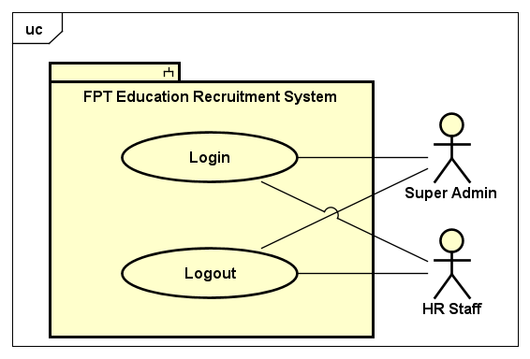

*Figure 1. Common use cases*

## 

*Figure 2. Candidate's use cases*

## 

*Figure 3. Super Admin's use cases*

## 

*Figure 4. HR Staff's use cases*

## ***2.2.2. Use cases***

|  |  |  |
| --- | --- | --- |
| **ID** | **Actor** | **Name** |
| UC-01 | Candidate | View recruitment process |
| UC-02 | Candidate | View home |
| UC-03 | Candidate | View all jobs |
| UC-04 | Candidate | View list jobs by region |
| UC-05 | Candidate | View list jobs by unit |
| UC-06 | Candidate | View job detail |
| UC-07 | Candidate | Search job |
| UC-08 | Candidate | Create CV |
| UC-09 | Candidate | Upload CV |
| UC-10 | Candidate | Register potential candidate |
| UC-11 | Candidate | Edit CV |
| UC-12 | Candidate | Take quiz |
| UC-13 | Super Admin | View all accounts |
| UC-14 | Super Admin | Add account |
| UC-15 | Super Admin | Edit account |
| UC-16 | Super Admin | Delete account |
| UC-17 | Super Admin | View all units |
| UC-18 | Super Admin | Add unit |
| UC-19 | Super Admin | Edit unit |
| UC-20 | Super Admin | Delete unit |
| UC-21 | Super Admin | View all locations |
| UC-22 | Super Admin | Add location |
| UC-23 | Super Admin | Edit location |
| UC-24 | Super Admin | Delete location |
| UC-25 | Super Admin | View all question groups |
| UC-26 | Super Admin | Add question group |
| UC-27 | Super Admin | Edit question group |
| UC-28 | Super Admin | Delete question group |
| UC-29 | Super Admin | View all questions |
| UC-30 | Super Admin | Add question |
| UC-31 | Super Admin | Edit question |
| UC-32 | Super Admin | Delete question |
| UC-33 | Super Admin | Search question |
| UC-34 | Super Admin | View all quizzes |
| UC-35 | Super Admin | Add quiz |
| UC-36 | Super Admin | Edit quiz |
| UC-37 | Super Admin | Delete quiz |
| UC-38 | Super Admin | View all careers |
| UC-39 | Super Admin | Add career |
| UC-40 | Super Admin | Edit career |
| UC-41 | Super Admin | Delete career |
| UC-42 | Super Admin | View all config emails |
| UC-43 | Super Admin | Add config email |
| UC-44 | Super Admin | Edit config email |
| UC-45 | Super Admin | Delete config email |
| UC-46 | Super Admin | View logs |
| UC-47 | Super Admin, Hr Staff | Login |
| UC-48 | Super Admin, Hr Staff | Logout |
| UC-49 | HR Staff | View all CVs |
| UC-50 | HR Staff | View detail CV |
| UC-51 | HR Staff | Change CV status |
| UC-52 | HR Staff | Search CV |
| UC-53 | HR Staff | Delete CV |
| UC-54 | HR Staff | Send email quiz |
| UC-55 | HR Staff | Export CV |
| UC-56 | HR Staff | View all jobs |
| UC-57 | HR Staff | Add job |
| UC-58 | HR Staff | Edit job |
| UC-59 | HR Staff | Delete job |
| UC-60 | HR Staff | Search job in HR |
| UC-61 | HR Staff | View list CVs applied for a job |
| UC-62 | HR Staff | View all error emails |
| UC-63 | HR Staff | Resend all error email |
| UC-64 | HR Staff | Resend each error email |

**2.2.3. System feature**

## ***2.2.3.1. Use case 01: View recruitment process***

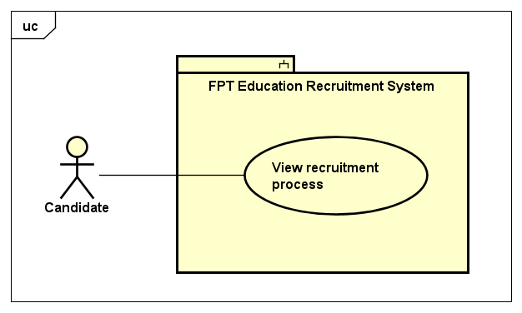

*Figure 5. View recruitment process*

## 

|  |  |  |  |  |
| --- | --- | --- | --- | --- |
| **USE CASE-01 SPECIFICATION** | | | | |
| **Use-case No.** | <UC01> | **Use-case Version** | | <1.0> |
| **Use-case Name** | View recruitment process | | | |
| **Author** | TungBT | | | |
| **Date** | 18/07/2020 | **Priority** | Low | |
| **Actor** | Candidate | | | |
| **Summary** | Candidate views information about recruitment process of FPT Education | | | |
| **Goal** | Display information about recruitment process | | | |
| **Triggers** | Candidate clicks on the link “Quy trình tuyển dụng” in the footer | | | |
| **Preconditions** | N/A | | | |
| **Post Conditions** | Candidate view information about recruitment process of FPT Education | | | |
| **Main Success Scenario** | | | | |
| |  |  |  | | --- | --- | --- | | **Step** | **Actor Events** | **System Response** | | **1** | Candidate clicks on “Quy trình tuyển dụng” in footer |  | | **2** |  | Redirect to recruitment process page | | | | | |
| **Alternative Scenario** | | | | |
| **N/A** | | | | |
| **Exceptions** |  | | | |
| **Business Rules** | N/A | | | |

## 

## ***2.2.3.2. Use case 02: View home***

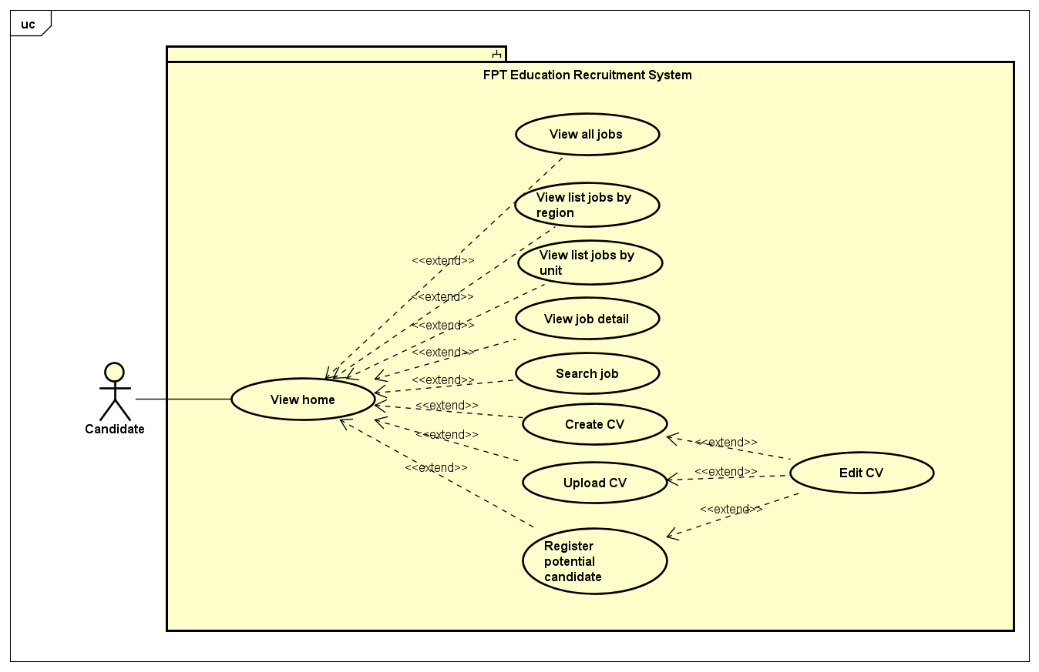

*Figure 6. View home use cases*

|  |  |  |  |  |
| --- | --- | --- | --- | --- |
| **USE CASE-02 SPECIFICATION** | | | | |
| **Use-case No.** | <UC02> | **Use-case Version** | | <1.0> |
| **Use-case Name** | View home | | | |
| **Author** | TungBT | | | |
| **Date** | 18/07/2020 | **Priority** | High | |
| **Actor** | Candidate | | | |
| **Summary** | Candidate view information in home page | | | |
| **Goal** | Display information in home page | | | |
| **Triggers** | Candidate visit the website in the browser | | | |
| **Preconditions** | N/A | | | |
| **Post Conditions** | Candidate view information in home page | | | |
| **Main Success Scenario** | | | | |
| |  |  |  | | --- | --- | --- | | **Step** | **Actor Events** | **System Response** | | **1** | User visit the website in the browser by typing url ***“career.fpt.edu.vn”*** |  | | **2** |  | Connect successfully, system display home page | | | | | |
| **Alternative Scenario** | | | | |
| **N/A** | | | | |
| **Exceptions** | N/A | | | |
| **Business Rules** | N/A | | | |

## 

## ***2.2.3.3 Use case 03: View all jobs***

|  |  |  |  |  |
| --- | --- | --- | --- | --- |
| **USE CASE-03 SPECIFICATION** | | | | |
| **Use-case No.** | <UC03> | **Use-case Version** | | <1.0> |
| **Use-case Name** | View all jobs | | | |
| **Author** | TungBT | | | |
| **Date** | 18/07/2020 | **Priority** | Medium | |
| **Actor** | Candidate | | | |
| **Summary** | Candidate views list of all the jobs that are in need of recruitment | | | |
| **Goal** | Display list of all jobs that are in need of recruitment | | | |
| **Triggers** | Click on the link “Vị trí tuyển dụng” on the header | | | |
| **Preconditions** | N/A | | | |
| **Post Conditions** | View list of all jobs | | | |
| **Main Success Scenario** | | | | |
| |  |  |  | | --- | --- | --- | | **Step** | **Actor Events** | **System Response** | | **1** | User visits FERS website |  | | **2** |  | Display home page default | | **3** | User clicks on the link “Vị trí tuyển dụng” on the header |  | | **4** |  | Redirect to list job page and display all jobs | | | | | |
| **Alternative Scenario** | | | | |
| **N/A** | | | | |
| **Exceptions** | N/A | | | |
| **Business Rules** | N/A | | | |

## 

## ***2.2.3.4. Use case 04: View list jobs by region***

|  |  |  |  |  |
| --- | --- | --- | --- | --- |
| **USE CASE-04 SPECIFICATION** | | | | |
| **Use-case No.** | <UC04> | **Use-case Version** | | <1.0> |
| **Use-case Name** | View list jobs by region | | | |
| **Author** | TungBT | | | |
| **Date** | 18/07/2020 | **Priority** | Medium | |
| **Actor** | Candidate | | | |
| **Summary** | Candidate views list of all jobs filtered by a region | | | |
| **Goal** | View list jobs filtered by a region | | | |
| **Triggers** | Click button “Xem thêm” on a section job of a region | | | |
| **Preconditions** | N/A | | | |
| **Post Conditions** | View list jobs filtered by a region | | | |
| **Main Success Scenario** | | | | |
| |  |  |  | | --- | --- | --- | | **Step** | **Actor Events** | **System Response** | | **1** | User visits FERS website |  | | **2** |  | Display home page default | | **3** | Click button “Xem thêm” on a section job of a region |  | | **4** |  | Redirect to list job page and show list of jobs filtered by the region user clicked on | | | | | |
| **Alternative Scenario** | | | | |
| **N/A** | | | | |
| **Exceptions** | N/A | | | |
| **Business Rules** | N/A | | | |

## ***2.2.3.5. Use case 05: View list jobs by unit***

|  |  |  |  |  |
| --- | --- | --- | --- | --- |
| **USE CASE-05 SPECIFICATION** | | | | |
| **Use-case No.** | <UC05> | **Use-case Version** | | <1.0> |
| **Use-case Name** | View list jobs by unit | | | |
| **Author** | TungBT | | | |
| **Date** | 18/07/2020 | **Priority** | Medium | |
| **Actor** | Candidate | | | |
| **Summary** | Candidate views list of all jobs filtered by an unit | | | |
| **Goal** | View list jobs filtered by an unit | | | |
| **Triggers** | Click on the unit link in the "Các vị trí tuyển dụng" section on the home page | | | |
| **Preconditions** | N/A | | | |
| **Post Conditions** | View list jobs filtered by an unit | | | |
| **Main Success Scenario** | | | | |
| |  |  |  | | --- | --- | --- | | **Step** | **Actor Events** | **System Response** | | **1** | User visits FERS website |  | | **2** |  | Display home page default | | **3** | Click on the unit link in the "Các vị trí tuyển dụng" section on the home page |  | | **4** |  | Redirect to list job page and show list of jobs filtered by the unit user clicked on | | | | | |
| **Alternative Scenario** | | | | |
| **N/A** | | | | |
| **Exceptions** | N/A | | | |
| **Business Rules** | N/A | | | |

## ***2.2.3.6 Use case 06: View job detail***

|  |  |  |  |  |
| --- | --- | --- | --- | --- |
| **USE CASE-06 SPECIFICATION** | | | | |
| **Use-case No.** | <UC06> | **Use-case Version** | | <1.0> |
| **Use-case Name** | View job detail | | | |
| **Author** | TungBT | | | |
| **Date** | 18/07/2020 | **Priority** | Medium | |
| **Actor** | Candidate | | | |
| **Summary** | Candidate view detailed information about a job | | | |
| **Goal** | Display detailed information about a job | | | |
| **Triggers** | Candidate click on a job | | | |
| **Preconditions** | N/A | | | |
| **Post Conditions** | Candidate view detailed information about a job | | | |
| **Main Success Scenario** | | | | |
| |  |  |  | | --- | --- | --- | | **Step** | **Actor Events** | **System Response** | | **1** | Candidate visits FERS website |  | | **2** |  | Display homepage | | **3** | Scroll down to top recruitment jobs section, then clicks to a job |  | | **5** |  | Redirect to job detail page and display detailed information about the job | | | | | |
| **Alternative Scenario** | | | | |
| Alternative Scenario 1:  |  |  |  | | --- | --- | --- | | **Step** | **Actor Events** | **System Response** | | **1** | Candidate visits FERS website |  | | **2** |  | Display homepage | | **3** | Candidate clicks “Xem thêm” to see list job filtered by region |  | | **4** |  | Move to list job page and display list jobs filtered by region | | **5** | Click on a job |  | | **6** |  | Move to job detail page and display detailed information about the job |  Alternative Scenario 2:  |  |  |  | | --- | --- | --- | | **Step** | **Actor Events** | **System Response** | | **1** | Candidate visits FERS website |  | | **2** |  | Display homepage | | **3** | Candidate clicks “Vị trí tuyển dụng” on header |  | | **4** |  | Redirect to list all jobs page and display all jobs that are in recruitment need | | **5** | Click on a job |  | | **6** |  | Move to job detail page and display detailed information about the job | | | | | |
| **Exceptions** | N/A | | | |
| **Business Rules** | N/A | | | |

## ***2.2.3.7 Use case 07: Search job***

|  |  |  |  |  |
| --- | --- | --- | --- | --- |
| **USE CASE-07 SPECIFICATION** | | | | |
| **Use-case No.** | <UC07> | **Use-case Version** | | <1.0> |
| **Use-case Name** | Search job | | | |
| **Author** | TungBT | | | |
| **Date** | 18/07/2020 | **Priority** | Medium | |
| **Actor** | Candidate | | | |
| **Summary** | Candidate find a job that he/she needs | | | |
| **Goal** | Display list of job filter by some input searching | | | |
| **Triggers** | Candidate chooses the options in filter menu (homepage) then click “Tìm kiếm” | | | |
| **Preconditions** | N/A | | | |
| **Post Conditions** | Candidate find a job that candidate needs | | | |
| **Main Success Scenario** | | | | |
| |  |  |  | | --- | --- | --- | | **Step** | **Actor Events** | **System Response** | | **1** | Candidate visits FERS website |  | | **2** |  | Display homepage | | **3** | Candidate fills in input fields on filter menu include:   1. Keyword (text) 2. Unit (drop down list) 3. Career (drop down list) 4. Location (drop down list)   Candidate clicks “Tìm kiếm” button |  | | **4** |  | Redirect to list job page and display the jobs filtered by searching keywords | | | | | |
| **Alternative Scenario** | | | | |
| **N/A** | | | | |
| **Exceptions** | N/A | | | |
| **Business Rules** | * All input fields must not be blank | | | |

## ***2.2.3.8 Use case 08: Create CV***

|  |  |  |  |  |
| --- | --- | --- | --- | --- |
| **USE CASE-08 SPECIFICATION** | | | | |
| **Use-case No.** | <UC08> | **Use-case Version** | | <1.0> |
| **Use-case Name** | Create CV | | | |
| **Author** | TungBT | | | |
| **Date** | 18/07/2020 | **Priority** | High | |
| **Actor** | Candidate | | | |
| **Summary** | Candidate create a CV to apply job | | | |
| **Goal** | Create CV a basic CV | | | |
| **Triggers** | Candidate click “Chưa có CV” on modal dialog | | | |
| **Preconditions** | N/A | | | |
| **Post Conditions** | Candidate create a CV | | | |
| **Main Success Scenario** | | | | |
| |  |  |  | | --- | --- | --- | | **Step** | **Actor Events** | **System Response** | | **1** | Candidate visits FERS website |  | | **2** |  | Display homepage | | **3** | Candidate click “Ứng tuyển ngay” on a detail job |  | | **4** |  | Display the confirmation dialog to ask if the candidate has a CV yet, include 2 options:   * “Chưa có CV” * “Đã có CV” | | **5** | Click “Chưa có CV” |  | | **6** |  | Display the create CV dialog | | **7** | Fill in the input fields then click “Nộp CV” |  | | **8** |  | Notice of success and redirect to homepage | | | | | |
| **Alternative Scenario** | | | | |
| |  |  |  | | --- | --- | --- | | **Step** | **Actor Events** | **System Response** | | **1** | Candidate visits FERS website |  | | **2** |  | Display homepage | | **3** | Candidate clicks “Xem thêm” to see list job filtered by region |  | | **4** |  | Move to list job page and display list jobs filtered by region | | **5** | Click on a job |  | | **6** |  | Move to job detail page and display detailed information about the job | | **7** | Candidate click the button “Ứng tuyển ngay” on a detail job page |  | | **8** |  | Display the confirmation dialog to ask if the candidate has a CV yet, include 2 options:   * “Chưa có CV” * “Đã có CV” | | **9** | Click “Chưa có CV” |  | | **10** |  | Display the create CV dialog | | **11** | Fill in the input fields then click “Nộp CV” |  | | **12** |  | Notice of success and redirect to homepage | | | | | |
| **Exceptions** | N/A | | | |
| **Business Rules** | * All input fields that include (*) must not be blank * The maximum length of input text fields is 255 * The maximum length of text area fields is 5000 | | | |

## ***2.2.3.9 Use case 09: Upload CV***

|  |  |  |  |  |
| --- | --- | --- | --- | --- |
| **USE CASE-09 SPECIFICATION** | | | | |
| **Use-case No.** | <UC09> | **Use-case Version** | | <1.0> |
| **Use-case Name** | Upload CV | | | |
| **Author** | TungBT | | | |
| **Date** | 18/07/2020 | **Priority** | High | |
| **Actor** | Candidate | | | |
| **Summary** | Once the candidate has a CV, he can upload it to the system | | | |
| **Goal** | Upload CV to the system to apply a job | | | |
| **Triggers** | Candidate click “Upload CV” on modal dialog | | | |
| **Preconditions** | N/A | | | |
| **Post Conditions** | Upload CV to the system | | | |
| **Main Success Scenario** | | | | |
| |  |  |  | | --- | --- | --- | | **Step** | **Actor Events** | **System Response** | | **1** | Candidate visits FERS website |  | | **2** |  | Display homepage | | **3** | Candidate click “Ứng tuyển ngay” on a detail job |  | | **4** |  | Display the confirmation dialog to ask if the candidate has a CV yet, include 2 options:   * “Chưa có CV” * “Đã có CV” | | **5** | Click “Chưa có CV” |  | | **6** |  | Show modal Upload CV | | **7** | Fill in the input fields then click “Nộp CV” |  | | **8** |  | Notice of successful CV upload | | | | | |
| **Alternative Scenario** | | | | |
| |  |  |  | | --- | --- | --- | | **Step** | **Actor Events** | **System Response** | | **1** | Candidate visits FERS website |  | | **2** |  | Display homepage | | **3** | Candidate clicks “Xem thêm” to see list job filtered by region |  | | **4** |  | Move to list job page and display list jobs filtered by region | | **5** | Click on a job |  | | **6** |  | Move to job detail page and display detailed information about the job | | **7** | Candidate click “Ứng tuyển ngay” on a detail job |  | | **8** |  | Display the confirmation dialog to ask if the candidate has a CV yet, include 2 options:   * “Chưa có CV” * “Đã có CV” | | **9** | Click “Chưa có CV” |  | | **10** |  | Show modal Upload CV | | **11** | Fill in the input fields then click “Nộp CV” |  | | **12** |  | Notice of successful CV upload | | | | | |
| **Exceptions** | * **Failed to upload CV file to server** The system gives notification and asks the user to re-upload | | | |
| **Business Rules** | * All input fields that include (*) must not be blank * The maximum length of input text fields is 255 * The maximum length of text area fields is 5000 * The maximum capacity of CV file is 5MB * CV file must be PDF | | | |

## ***2.2.3.10 Use case 10: Register potential candidate***

|  |  |  |  |  |
| --- | --- | --- | --- | --- |
| **USE CASE-10 SPECIFICATION** | | | | |
| **Use-case No.** | <UC10> | **Use-case Version** | | <1.0> |
| **Use-case Name** | Register potential candidate | | | |
| **Author** | TungBT | | | |
| **Date** | 18/07/2020 | **Priority** | Low | |
| **Actor** | Candidate | | | |
| **Summary** | When the candidate has not found the desired job, but they intend to apply in the future, they can leave personal information for HR staff to advise them. | | | |
| **Goal** | Candidate register information | | | |
| **Triggers** | Candidate clicks on the button “Đăng ký” in Homepage | | | |
| **Preconditions** | N/A | | | |
| **Post Conditions** | Candidate submit form to send information to the system | | | |
| **Main Success Scenario** | | | | |
| |  |  |  | | --- | --- | --- | | **Step** | **Actor Events** | **System Response** | | **1** | Candidate visits FERS website |  | | **2** |  | Display homepage | | **3** | Click on the button “Đăng ký” |  | | **4** |  | Display modal register potential candidate | | **5** | Fill in all input fields and click “Đăng ký” |  | | **6** |  | Notice of success and close dialog | | | | | |
| **Alternative Scenario** | | | | |
| |  |  |  | | --- | --- | --- | | **Step** | **Actor Events** | **System Response** | | **1** | Candidate visits FERS website |  | | **2** |  | Display homepage | | **3** | Click the link “Gia nhập với chúng tôi” on the header |  | | **4** |  | Display modal register potential candidate | | **5** | Fill in all input fields and click “Đăng ký” |  | | **6** |  | Notice of success and close dialog | | | | | |
| **Exceptions** | N/A | | | |
| **Business Rules** | * All input fields that include (*) must not be blank * The maximum length of input text fields is 255 * The maximum length of text area fields is 5000 | | | |

## ***2.2.3.11 Use case 11: Edit CV***

|  |  |  |  |  |
| --- | --- | --- | --- | --- |
| **USE CASE-11 SPECIFICATION** | | | | |
| **Use-case No.** | <UC11> | **Use-case Version** | | <1.0> |
| **Use-case Name** | Edit CV | | | |
| **Author** | TungBT | | | |
| **Date** | 18/07/2020 | **Priority** | Medium | |
| **Actor** | Candidate | | | |
| **Summary** | After successfully creating a simple CV on the system, an email will be sent to the candidate, including a link to the page where candidates can edit their CV. | | | |
| **Goal** | Edit the CV | | | |
| **Triggers** | N/A | | | |
| **Preconditions** | Candidates successfully submit their CV by creating it directly on the system | | | |
| **Post Conditions** | Edit the CV | | | |
| **Main Success Scenario** | | | | |
| |  |  |  | | --- | --- | --- | | **Step** | **Actor Events** | **System Response** | | **1** | Do a normal flow of one of the following use case:   * UC-08: Create CV * UC-09: Upload CV * UC-10: Register potential candidate |  | | **2** |  | Send an email to the candidate, including a link to the page where candidates can edit their CV. | | **3** | Candidate clicks the link |  | | **4** |  | Redirect to edit CV page | | **5** | Candidate edits information of the CV and clicks submit button |  | | **6** |  | Notice of success then display home page | | | | | |
| **Alternative Scenario** | | | | |
| **N/A** | | | | |
| **Exceptions** | N/A | | | |
| **Business Rules** | * All input fields that include (*) must not be blank * The maximum length of input text fields is 255 * The maximum length of text area fields is 5000 | | | |

## 

## ***2.2.3.12. Use case 12: Take quiz***

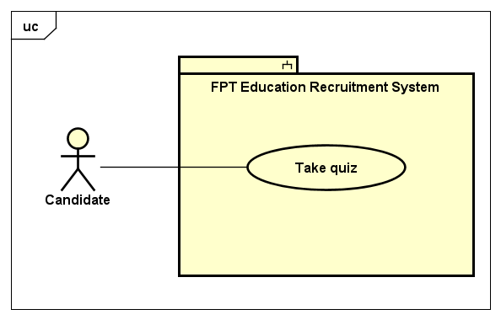

*Figure 7. Take quiz use case*

## 

|  |  |  |  |  |
| --- | --- | --- | --- | --- |
| **USE CASE-12 SPECIFICATION** | | | | |
| **Use-case No.** | <UC12> | **Use-case Version** | | <1.0> |
| **Use-case Name** | Take quiz | | | |
| **Author** | TungBT | | | |
| **Date** | 18/07/2020 | **Priority** | Medium | |
| **Actor** | Candidate | | | |
| **Summary** | Candidate received a document about FPT Education to learn about FE, then do a small quiz | | | |
| **Goal** | Help candidate to understand more about FPT Education | | | |
| **Triggers** | N/A | | | |
| **Preconditions** | HR Staff clicks send mail to the candidate to take quiz | | | |
| **Post Conditions** | Candidate do a small quiz about FPT Education | | | |
| **Main Success Scenario** | | | | |
| |  |  |  | | --- | --- | --- | | **Step** | **Actor Events** | **System Response** | | **1** | After HR Staff does normal flow of UC-54 (Send email quiz), Candidate will be received an email that includes link to the quiz  Candidate clicks to the link to the quiz |  | | **2** |  | Redirect to the quiz page | | **3** | After answer all questions, candidate click the button “Nộp bài” to submit the quiz |  | | **4** |  | Display success message: "Chúc mừng bạn đã hoàn thành bài kiểm tra !" | | | | | |
| **Alternative Scenario** | | | | |
| **N/A** | | | | |
| **Exceptions** | N/A | | | |
| **Business Rules** | Each question has one or more right answers  * Time for a quiz is 40 minutes | | | |

## 

## ***2.2.3.13 Use case 13: View all accounts***

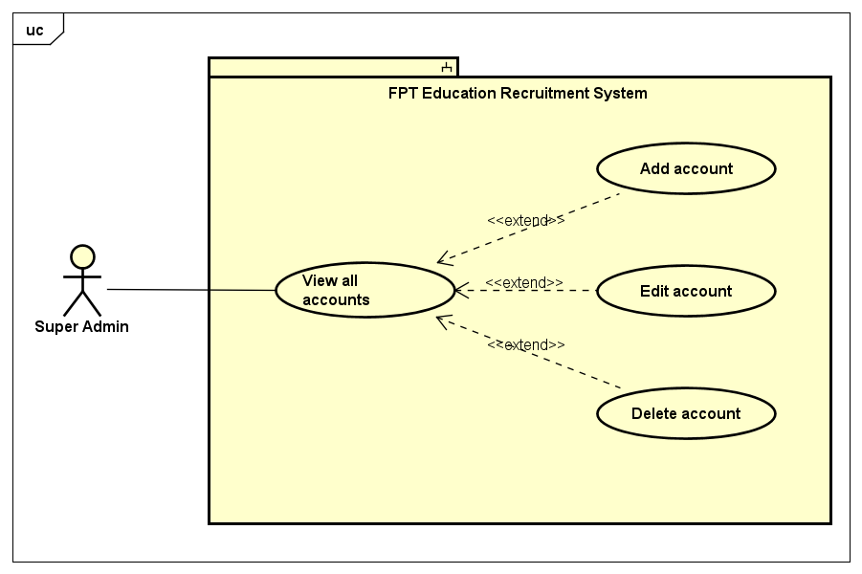

*Figure 8. Account management use cases*

## 

|  |  |  |  |  |
| --- | --- | --- | --- | --- |
| **USE CASE-13 SPECIFICATION** | | | | |
| **Use-case No.** | <UC13> | **Use-case Version** | | <1.0> |
| **Use-case Name** | View all accounts | | | |
| **Author** | TungBT | | | |
| **Date** | 18/07/2020 | **Priority** | Medium | |
| **Actor** | Super Admin | | | |
| **Summary** | Super Admin view all accounts in the system | | | |
| **Goal** | View all accounts in the system | | | |
| **Triggers** | Super Admin clicks tab “Quản lý tài khoản” on the sidebar of admin dashboard | | | |
| **Preconditions** | User has successfully logged in to the system as the Super Admin role | | | |
| **Post Conditions** | Super Admin views table of accounts | | | |
| **Main Success Scenario** | | | | |
| |  |  |  | | --- | --- | --- | | **Step** | **Actor Events** | **System Response** | | **1** | User logins as role of Super Admin |  | | **2** |  | Display admin dashboard with account management tab default | | | | | |
| **Alternative Scenario** | | | | |
| **N/A** | | | | |
| **Exceptions** | N/A | | | |
| **Business Rules** | N/A | | | |

## ***2.2.3.14. Use case 14: Add account***

|  |  |  |  |  |
| --- | --- | --- | --- | --- |
| **USE CASE-14 SPECIFICATION** | | | | |
| **Use-case No.** | <UC14> | **Use-case Version** | | <1.0> |
| **Use-case Name** | Add account | | | |
| **Author** | TungBT | | | |
| **Date** | 18/07/2020 | **Priority** | Medium | |
| **Actor** | Super Admin | | | |
| **Summary** | Super Admin adds an account to the system | | | |
| **Goal** | Add a new account | | | |
| **Triggers** | Super Admin clicks “Tạo tài khoản mới” button on account management page | | | |
| **Preconditions** | User has successfully logged in to the system as the Super Admin role | | | |
| **Post Conditions** | Add a new account to the system | | | |
| **Main Success Scenario** | | | | |
| |  |  |  | | --- | --- | --- | | **Step** | **Actor Events** | **System Response** | | **1** | User logins as role of Super Admin |  | | **2** |  | Display account management page | | **3** | Click on “Tạo tài khoản mới” button |  | | **4** |  | Redirect to create account page | | **5** | Fill in all input fields and submit the form |  | | **6** |  | If creating successfully, the system will redirect to the account manage page and notify a success message  If creating error, the system will redirect to the error page and show message of the error | | | | | |
| **Alternative Scenario** | | | | |
| **N/A** | | | | |
| **Exceptions** | N/A | | | |
| **Business Rules** | Email must be valid type of email and not duplicate | | | |

## ***2.2.3.15. Use case 15: Edit account***

|  |  |  |  |  |
| --- | --- | --- | --- | --- |
| **USE CASE-15 SPECIFICATION** | | | | |
| **Use-case No.** | <UC15> | **Use-case Version** | | <1.0> |
| **Use-case Name** | Edit account | | | |
| **Author** | TungBT | | | |
| **Date** | 18/07/2020 | **Priority** | Medium | |
| **Actor** | Super Admin | | | |
| **Summary** | User has successfully logged in to the system as the Super Admin role | | | |
| **Goal** | Edit an existing account | | | |
| **Triggers** | Super Admin clicks “Sửa” button on an account when view all accounts | | | |
| **Preconditions** | User has successfully logged in to the system as the Super Admin role | | | |
| **Post Conditions** | Edit information about the account | | | |
| **Main Success Scenario** | | | | |
| |  |  |  | | --- | --- | --- | | **Step** | **Actor Events** | **System Response** | | **1** | Do a normal flow of UC-13 |  | | **2** |  | Display all accounts of the system | | **3** | Click “Sửa” button on an account |  | | **4** |  | Display edit account page | | **5** | Edit information of the account and submit the form |  | | **6** |  | Notice of success and back to account management page | | | | | |
| **Alternative Scenario** | | | | |
| **N/A** | | | | |
| **Exceptions** | N/A | | | |
| **Business Rules** | Email must be valid type of email and not duplicate | | | |

## ***2.2.3.16. Use case 16: Delete account***

|  |  |  |  |  |
| --- | --- | --- | --- | --- |
| **USE CASE-16 SPECIFICATION** | | | | |
| **Use-case No.** | <UC16> | **Use-case Version** | | <1.0> |
| **Use-case Name** | Delete account | | | |
| **Author** | TungBT | | | |
| **Date** | 18/07/2020 | **Priority** | Medium | |
| **Actor** | Super Admin | | | |
| **Summary** | Super Admin deletes an account in the system | | | |
| **Goal** | Delete an account | | | |
| **Triggers** | Super Admin clicks “Xoá” button on account management page | | | |
| **Preconditions** | User has successfully logged in to the system as the Super Admin role | | | |
| **Post Conditions** | Delete an account | | | |
| **Main Success Scenario** | | | | |
| |  |  |  | | --- | --- | --- | | **Step** | **Actor Events** | **System Response** | | **1** | Do a normal flow of UC-13 |  | | **2** |  | Display all accounts of the system | | **3** | Click “Xoá” button on an account |  | | **4** |  | Give a confirmation message | | **5** | Confirm to delete the account |  | | **6** |  | Delete the account then display account management page | | | | | |
| **Alternative Scenario** | | | | |
|  | | | | |
| **Exceptions** | N/A | | | |
| **Business Rules** | Super Admin can not delete account of himself | | | |

## 

## ***2.2.3.17. Use case 17: View all units***

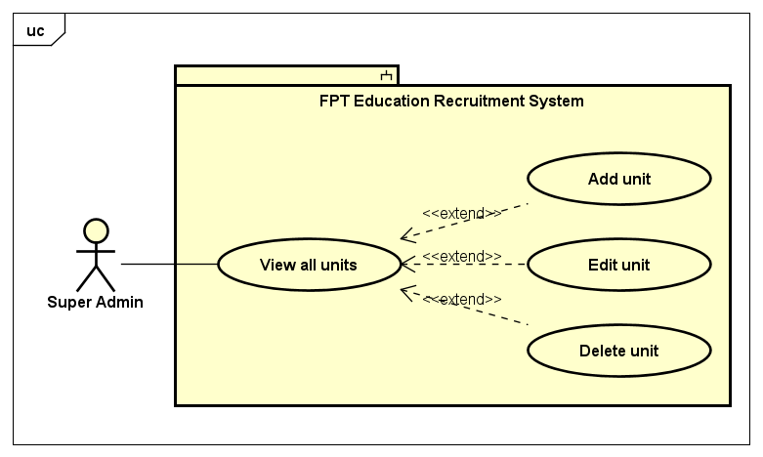

*Figure 9. Unit management use cases*

|  |  |  |  |  |
| --- | --- | --- | --- | --- |
| **USE CASE-17 SPECIFICATION** | | | | |
| **Use-case No.** | <UC17> | **Use-case Version** | | <1.0> |
| **Use-case Name** | View all units | | | |
| **Author** | TungBT | | | |
| **Date** | 18/07/2020 | **Priority** | Medium | |
| **Actor** | Super Admin | | | |
| **Summary** | Super admin accesses the unit management page and views all units of the system | | | |
| **Goal** | View list of units in FPT Education system | | | |
| **Triggers** | User clicks the tab “Quản lý đơn vị” on the sidebar of admin dashboard | | | |
| **Preconditions** | User has successfully logged in to the system as the Super Admin role | | | |
| **Post Conditions** | View list of units in FPT Education system | | | |
| **Main Success Scenario** | | | | |
| |  |  |  | | --- | --- | --- | | **Step** | **Actor Events** | **System Response** | | **1** | User logins as Super Admin role |  | | **2** |  | Display Account management page by default | | **3** | User clicks on “Quản lý đơn vị” tab on the sidebar |  | | **4** |  | Display unit management page | | | | | |
| **Alternative Scenario** | | | | |
| **N/A** | | | | |
| **Exceptions** | N/A | | | |
| **Business Rules** | N/A | | | |

## 

## ***2.2.3.18. Use case 18: Add unit***

|  |  |  |  |  |
| --- | --- | --- | --- | --- |
| **USE CASE-18 SPECIFICATION** | | | | |
| **Use-case No.** | <UC18> | **Use-case Version** | | <1.0> |
| **Use-case Name** | Add unit | | | |
| **Author** | TungBT | | | |
| **Date** | 18/07/2020 | **Priority** | Low | |
| **Actor** | Super Admin | | | |
| **Summary** | Super Admin creates a new unit into FPT Education system | | | |
| **Goal** | Create a new unit | | | |
| **Triggers** | User clicks on “Thêm đơn vị làm việc” button on unit management page | | | |
| **Preconditions** | User has successfully logged in to the system as the Super Admin role | | | |
| **Post Conditions** | Create a new unit into the system | | | |
| **Main Success Scenario** | | | | |
| |  |  |  | | --- | --- | --- | | **Step** | **Actor Events** | **System Response** | | **1** | Do a normal flow of UC-17 and click on “Thêm đơn vị làm việc” button |  | | **2** |  | Display create an unit page | | **3** | Enter information in the input fields then click submit button |  | | **4** |  | Notice of success and redirect to unit management page | | | | | |
| **Alternative Scenario** | | | | |
| **N/A** | | | | |
| **Exceptions** | N/A | | | |
| **Business Rules** | Maximum size of image file is 5MB | | | |

## ***2.2.3.19. Use case 19: Edit unit***

|  |  |  |  |  |
| --- | --- | --- | --- | --- |
| **USE CASE-19 SPECIFICATION** | | | | |
| **Use-case No.** | <UC19> | **Use-case Version** | | <1.0> |
| **Use-case Name** | Edit unit | | | |
| **Author** | TungBT | | | |
| **Date** | 18/07/2020 | **Priority** | Low | |
| **Actor** | Super Admin | | | |
| **Summary** | Super Admin edits information of an unit in FPT Education system | | | |
| **Goal** | Edit information of an unit | | | |
| **Triggers** | Click on “Sửa” button of an unit | | | |
| **Preconditions** | User has successfully logged in to the system as the Super Admin role | | | |
| **Post Conditions** | Edit an unit | | | |
| **Main Success Scenario** | | | | |
| |  |  |  | | --- | --- | --- | | **Step** | **Actor Events** | **System Response** | | **1** | Do a normal flow of UC-17 |  | | **2** |  | Display unit management page | | **3** | Click on “Sửa” button of an unit |  | | **4** |  | Display edit an unit page | | **5** | Edit information of the unit then submit form |  | | **6** |  | Notice of success then redirect to unit management page | | | | | |
| **Alternative Scenario** | | | | |
| **N/A** | | | | |
| **Exceptions** | N/A | | | |
| **Business Rules** | Maximum length of unit’s name is 255 | | | |

## 

## ***2.2.3.20. Use case 20: Delete unit***

|  |  |  |  |  |
| --- | --- | --- | --- | --- |
| **USE CASE-20 SPECIFICATION** | | | | |
| **Use-case No.** | <UC20> | **Use-case Version** | | <1.0> |
| **Use-case Name** | Delete unit | | | |
| **Author** | TungBT | | | |
| **Date** | 18/07/2020 | **Priority** | Low | |
| **Actor** | Super Admin | | | |
| **Summary** | Super Admin deletes an unit of FPT Education system | | | |
| **Goal** | Delete an unit | | | |
| **Triggers** | Click on “Xoá” button of an unit | | | |
| **Preconditions** | User has successfully logged in to the system as the Super Admin role | | | |
| **Post Conditions** | Delete an unit | | | |
| **Main Success Scenario** | | | | |
| |  |  |  | | --- | --- | --- | | **Step** | **Actor Events** | **System Response** | | **1** | Do a normal flow of UC-17 |  | | **2** |  | Display unit management page | | **3** | User clicks on “Xoá” button of an unit |  | | **4** |  | Give confirmation dialog box | | **5** | Confirm to delete the unit |  | | **6** |  | Delete the unit then display unit management page | | | | | |
| **Alternative Scenario** | | | | |
| **N/A** | | | | |
| **Exceptions** | N/A | | | |
| **Business Rules** | N/A | | | |

## 

## ***2.2.3.21. Use case 21: View all locations***

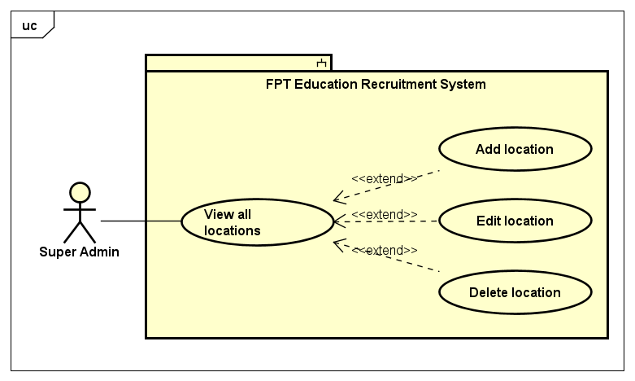

*Figure 10. Location management use cases*

|  |  |  |  |  |
| --- | --- | --- | --- | --- |
| **USE CASE-21 SPECIFICATION** | | | | |
| **Use-case No.** | <UC21> | **Use-case Version** | | <1.0> |
| **Use-case Name** | View all locations | | | |
| **Author** | TungBT | | | |
| **Date** | 18/07/2020 | **Priority** | Medium | |
| **Actor** | Super Admin | | | |
| **Summary** | Super Admin views all locations of FPT Education system, these are provinces and cities of Vietnam | | | |
| **Goal** | View all locations of FPT Education system | | | |
| **Triggers** | User clicks the tab “Quản lý địa điểm” on the sidebar of admin dashboard | | | |
| **Preconditions** | User has successfully logged in to the system as the Super Admin role | | | |
| **Post Conditions** | View list of locations in FPT Education system | | | |
| **Main Success Scenario** | | | | |
| |  |  |  | | --- | --- | --- | | **Step** | **Actor Events** | **System Response** | | **1** | User logins as Super Admin role |  | | **2** |  | Display account management page by default | | **3** | User clicks on “Quản lý địa điểm” tab on the sidebar |  | | **4** |  | Display location management page | | | | | |
| **Alternative Scenario** | | | | |
| **N/A** | | | | |
| **Exceptions** | N/A | | | |
| **Business Rules** | N/A | | | |

## ***2.2.3.22. Use case 22: Add location***

|  |  |  |  |  |
| --- | --- | --- | --- | --- |
| **USE CASE-22 SPECIFICATION** | | | | |
| **Use-case No.** | <UC22> | **Use-case Version** | | <1.0> |
| **Use-case Name** | Add location | | | |
| **Author** | TungBT | | | |
| **Date** | 18/07/2020 | **Priority** | Medium | |
| **Actor** | Super Admin | | | |
| **Summary** | Super Admin adds a new location into FPT Education system | | | |
| **Goal** | Add a new location | | | |
| **Triggers** | User clicks on “Thêm địa điểm mới” button on location management page | | | |
| **Preconditions** | User has successfully logged in to the system as the Super Admin role | | | |
| **Post Conditions** | Add a new location into the system | | | |
| **Main Success Scenario** | | | | |
| |  |  |  | | --- | --- | --- | | **Step** | **Actor Events** | **System Response** | | **1** | Do a normal flow of UC-21 and click on “Thêm địa điểm mới” button |  | | **2** |  | Display add a location page | | **3** | Fill information in the input fields then click submit button |  | | **4** |  | Notice of success and redirect to location management page | | | | | |
| **Alternative Scenario** | | | | |
| **N/A** | | | | |
| **Exceptions** | N/A | | | |
| **Business Rules** | Max length of the location name is 255 | | | |

## ***2.2.3.23. Use case 23: Edit location***

|  |  |  |  |  |
| --- | --- | --- | --- | --- |
| **USE CASE-23 SPECIFICATION** | | | | |
| **Use-case No.** | <UC23> | **Use-case Version** | | <1.0> |
| **Use-case Name** | Edit location | | | |
| **Author** | TungBT | | | |
| **Date** | 18/07/2020 | **Priority** | Medium | |
| **Actor** | Super Admin | | | |
| **Summary** | Super Admin edits information of a location in FPT Education system | | | |
| **Goal** | Edit information of a location | | | |
| **Triggers** | Click on “Sửa” button of a location | | | |
| **Preconditions** | User has successfully logged in to the system as the Super Admin role | | | |
| **Post Conditions** | Edit a location | | | |
| **Main Success Scenario** | | | | |
| |  |  |  | | --- | --- | --- | | **Step** | **Actor Events** | **System Response** | | **1** | Do a normal flow of UC-21 |  | | **2** |  | Display location management page | | **3** | Click on “Sửa” button of a location |  | | **4** |  | Display edit location page | | **5** | Edit information of the location then submit form |  | | **6** |  | Notice of success then redirect to location management page | | | | | |
| **Alternative Scenario** | | | | |
| **N/A** | | | | |
| **Exceptions** | N/A | | | |
| **Business Rules** | Max length of unit name is 255 | | | |

## ***2.2.3.24. Use case 24: Delete location***

|  |  |  |  |  |
| --- | --- | --- | --- | --- |
| **USE CASE-24 SPECIFICATION** | | | | |
| **Use-case No.** | <UC24> | **Use-case Version** | | <1.0> |
| **Use-case Name** | Delete location | | | |
| **Author** | TungBT | | | |
| **Date** | 18/07/2020 | **Priority** | Medium | |
| **Actor** | Super Admin | | | |
| **Summary** | Super Admin deletes a location of FPT Education system | | | |
| **Goal** | Delete a location | | | |
| **Triggers** | Click on “Xóa” button on a location | | | |
| **Preconditions** | User has successfully logged in to the system as the Super Admin role | | | |
| **Post Conditions** | Delete a location | | | |
| **Main Success Scenario** | | | | |
| |  |  |  | | --- | --- | --- | | **Step** | **Actor Events** | **System Response** | | **1** | Do a normal flow of UC-21 |  | | **2** |  | Display location management page | | **3** | User clicks on “Xóa” button on a location |  | | **4** |  | Give confirmation message | | **5** | Confirm to delete the location |  | | **6** |  | Delete the location then display location management page | | | | | |
| **Alternative Scenario** | | | | |
| **N/A** | | | | |
| **Exceptions** | N/A | | | |
| **Business Rules** | N/A | | | |

## 

## ***2.2.3.25. Use case 25: View all question groups***

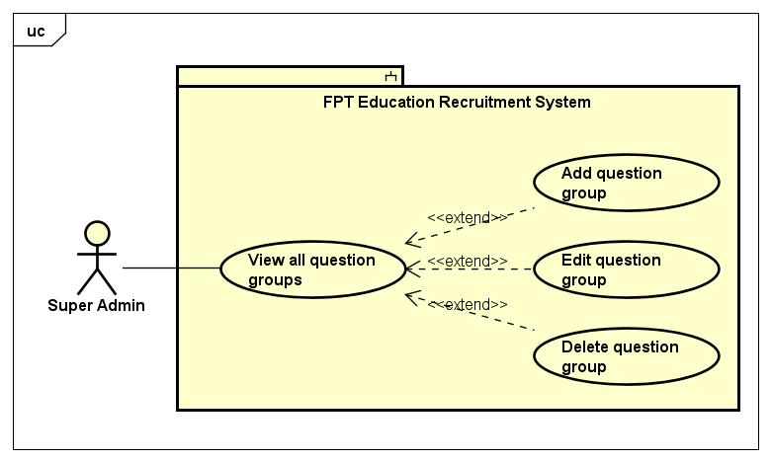

*Figure 11. Question group management use cases*

|  |  |  |  |  |
| --- | --- | --- | --- | --- |
| **USE CASE-25 SPECIFICATION** | | | | |
| **Use-case No.** | <UC25> | **Use-case Version** | | <1.0> |
| **Use-case Name** | View all question groups | | | |
| **Author** | TungBT | | | |
| **Date** | 18/07/2020 | **Priority** | Low | |
| **Actor** | Super Admin | | | |
| **Summary** | Super Admin views all question groups in the system. The questions are divided into groups, each group corresponding to a different topic for easy management | | | |
| **Goal** | View all question groups | | | |
| **Triggers** | User clicks on the tab “Quản lý nhóm câu hỏi” on the sidebar of website | | | |
| **Preconditions** | User has successfully logged in to the system as the Super Admin role | | | |
| **Post Conditions** | View all question groups | | | |
| **Main Success Scenario** | | | | |
| |  |  |  | | --- | --- | --- | | **Step** | **Actor Events** | **System Response** | | **1** | User logins to the system as role of Super Admin |  | | **2** |  | Display account management page by default | | **3** | User clicks on the tab “Quản lý nhóm câu hỏi” on the sidebar |  | | **4** |  | Display list of question groups on question group management page | | | | | |
| **Alternative Scenario** | | | | |
| **N/A** | | | | |
| **Exceptions** | N/A | | | |
| **Business Rules** | N/A | | | |

## ***2.2.3.26. Use case 26: Add question group***

|  |  |  |  |  |
| --- | --- | --- | --- | --- |
| **USE CASE-26 SPECIFICATION** | | | | |
| **Use-case No.** | <UC26> | **Use-case Version** | | <1.0> |
| **Use-case Name** | Add question group | | | |
| **Author** | TungBT | | | |
| **Date** | 18/07/2020 | **Priority** | Low | |
| **Actor** | Super Admin | | | |
| **Summary** | Super Admin adds a new question group | | | |
| **Goal** | Add a new question group | | | |
| **Triggers** | User clicks the button “Tạo nhóm mới” on question group management page | | | |
| **Preconditions** | User has successfully logged in to the system as the Super Admin role | | | |
| **Post Conditions** | Add a new question group | | | |
| **Main Success Scenario** | | | | |
| |  |  |  | | --- | --- | --- | | **Step** | **Actor Events** | **System Response** | | **1** | Do a normal flow of UC-25 |  | | **2** |  | Display question group management page | | **3** | User clicks on the button “Tạo nhóm mới” |  | | **4** |  | Display add question group page | | **5** | User enters name of the new question group and clicks “Tạo mới” |  | | **6** |  | Notice of success and display question group management page | | | | | |
| **Alternative Scenario** | | | | |
| **N/A** | | | | |
| **Exceptions** | N/A | | | |
| **Business Rules** | N/A | | | |

## ***2.2.3.27. Use case 27: Edit question group***

|  |  |  |  |  |
| --- | --- | --- | --- | --- |
| **USE CASE-27 SPECIFICATION** | | | | |
| **Use-case No.** | <UC27> | **Use-case Version** | | <1.0> |
| **Use-case Name** | Edit question group | | | |
| **Author** | TungBT | | | |
| **Date** | 18/07/2020 | **Priority** | Low | |
| **Actor** | Super Admin | | | |
| **Summary** | Super Admin edit the name of a question group | | | |
| **Goal** | Edit a question group | | | |
| **Triggers** | User clicks button “Sửa” of a question group | | | |
| **Preconditions** | User has successfully logged in to the system as the Super Admin role | | | |
| **Post Conditions** | Edit a question group | | | |
| **Main Success Scenario** | | | | |
| |  |  |  | | --- | --- | --- | | **Step** | **Actor Events** | **System Response** | | **1** | Do a normal flow of UC-25 |  | | **2** |  | Display question group management page | | **3** | User clicks the button “Sửa” on a question group |  | | **4** |  | Display edit question group page | | **5** | User changes the name of the question group |  | | **6** | User clicks “Lưu” to complete editing |  | | **7** |  | Notice of success and display question group management page | | | | | |
| **Alternative Scenario** | | | | |
| **N/A** | | | | |
| **Exceptions** | N/A | | | |
| **Business Rules** | Name of question group must not be blank  * Max length of the name of question group is 255 | | | |

## ***2.2.3.28. Use case 28: Delete question group***

|  |  |  |  |  |
| --- | --- | --- | --- | --- |
| **USE CASE-28 SPECIFICATION** | | | | |
| **Use-case No.** | <UC28> | **Use-case Version** | | <1.0> |
| **Use-case Name** | Delete question group | | | |
| **Author** | TungBT | | | |
| **Date** | 18/07/2020 | **Priority** | Low | |
| **Actor** | Super Admin | | | |
| **Summary** | Super Admin deletes a question group | | | |
| **Goal** | Delete a question group | | | |
| **Triggers** | User clicks button “Xóa” of a question group | | | |
| **Preconditions** | User has successfully logged in to the system as the Super Admin role | | | |
| **Post Conditions** | Delete a question group | | | |
| **Main Success Scenario** | | | | |
| |  |  |  | | --- | --- | --- | | **Step** | **Actor Events** | **System Response** | | **1** | Do a normal flow of UC-25 |  | | **2** |  | Display question group management page | | **3** | User clicks the button “Xóa” on a question group |  | | **4** |  | Pop up a confirmation dialog box | | **5** | User clicks OK to confirm delete |  | | **6** |  | The system notifies that the question group has been successfully deleted, then refresh page | | | | | |
| **Alternative Scenario** | | | | |
| **N/A** | | | | |
| **Exceptions** | N/A | | | |
| **Business Rules** | N/A | | | |

## ***2.2.3.29. Use case 29: View all questions***

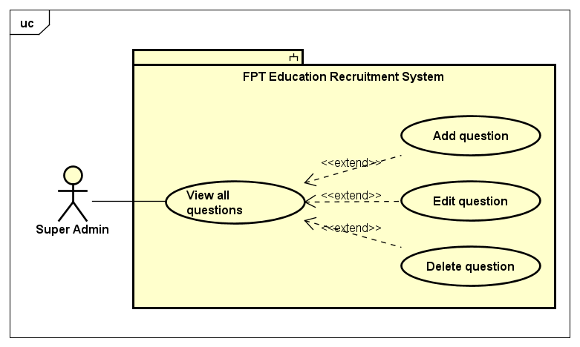

*Figure 12. Question management use cases*

## 

|  |  |  |  |  |
| --- | --- | --- | --- | --- |
| **USE CASE-29 SPECIFICATION** | | | | |
| **Use-case No.** | <UC29> | **Use-case Version** | | <1.0> |
| **Use-case Name** | View all questions | | | |
| **Author** | TungBT | | | |
| **Date** | 18/07/2020 | **Priority** | Medium | |
| **Actor** | Super Admin | | | |
| **Summary** | Super Admin views list of all questions in the system | | | |
| **Goal** | View all questions | | | |
| **Triggers** | Click tab “Quản lý câu hỏi” in the sidebar | | | |
| **Preconditions** | User has successfully logged in to the system as the Super Admin role | | | |
| **Post Conditions** | System show list of questions | | | |
| **Main Success Scenario** | | | | |
| |  |  |  | | --- | --- | --- | | **Step** | **Actor Events** | **System Response** | | **1** | User logins as role of Super Admin |  | | **2** |  | Display account management page by default | | **3** | User clicks on “Quản lý câu hỏi” tab on the sidebar |  | | **4** |  | Redirect to question management page, show list of all questions | | | | | |
| **Alternative Scenario** | | | | |
| **N/A** | | | | |
| **Exceptions** | N/A | | | |
| **Business Rules** | N/A | | | |

## 

## ***2.2.3.30. Use case 30: Add question***

|  |  |  |  |  |
| --- | --- | --- | --- | --- |
| **USE CASE-30 SPECIFICATION** | | | | |
| **Use-case No.** | <UC30> | **Use-case Version** | | <1.0> |
| **Use-case Name** | Add question | | | |
| **Author** | TungBT | | | |
| **Date** | 18/07/2020 | **Priority** | Medium | |
| **Actor** | Super Admin | | | |
| **Summary** | Super admin adds a new question into question bank | | | |
| **Goal** | Add a new question | | | |
| **Triggers** | User clicks on “Thêm câu hỏi mới” button on question management page | | | |
| **Preconditions** | User has successfully logged in to the system as the Super Admin role | | | |
| **Post Conditions** | Add a new question into question bank | | | |
| **Main Success Scenario** | | | | |
| |  |  |  | | --- | --- | --- | | **Step** | **Actor Events** | **System Response** | | **1** | Do a normal flow of UC-29 |  | | **2** |  | Display question management page | | **3** | User clicks on “Thêm câu hỏi mới” button |  | | **4** |  | Display add question page | | **5** | Enter information in the input fields then click submit button |  | | **6** |  | Notice of success and move to question management page | | | | | |
| **Alternative Scenario** | | | | |
|  | | | | |
| **Exceptions** | N/A | | | |
| **Business Rules** | Each question must have at least one correct answer  * Max length of question name field is 255 | | | |

## ***2.2.3.31. Use case 31: Edit question***

|  |  |  |  |  |
| --- | --- | --- | --- | --- |
| **USE CASE-31 SPECIFICATION** | | | | |
| **Use-case No.** | <UC31> | **Use-case Version** | | <1.0> |
| **Use-case Name** | Edit question | | | |
| **Author** | TungBT | | | |
| **Date** | 18/07/2020 | **Priority** | Medium | |
| **Actor** | Super Admin | | | |
| **Summary** | Super Admin edits a question in question bank | | | |
| **Goal** | Edit a question | | | |
| **Triggers** | Click on “Sửa” button of an question | | | |
| **Preconditions** | User has successfully logged in to the system as the Super Admin role | | | |
| **Post Conditions** | Edit a question | | | |
| **Main Success Scenario** | | | | |
| |  |  |  | | --- | --- | --- | | **Step** | **Actor Events** | **System Response** | | **1** | Do a normal flow of UC-29 |  | | **2** |  | Display list of question | | **3** | User clicks on “Sửa” button of a question |  | | **4** |  | Display edit question page | | **5** | User edits input fields and clicks submit button |  | | **6** |  | Notice of success and back to manage question page | | | | | |
| **Alternative Scenario** | | | | |
| **N/A** | | | | |
| **Exceptions** | N/A | | | |
| **Business Rules** | Each question can have one or more correct answers  * Max length of question name field is 255 | | | |

## ***2.2.3.32. Use case 32: Delete question***

|  |  |  |  |  |
| --- | --- | --- | --- | --- |
| **USE CASE-32 SPECIFICATION** | | | | |
| **Use-case No.** | <UC32> | **Use-case Version** | | <1.0> |
| **Use-case Name** | Delete question | | | |
| **Author** | TungBT | | | |
| **Date** | 18/07/2020 | **Priority** | Low | |
| **Actor** | Super Admin | | | |
| **Summary** | Super Admin deletes a question in question bank | | | |
| **Goal** | Delete a question | | | |
| **Triggers** | Click on “Xóa” button of a question | | | |
| **Preconditions** | User has successfully logged in to the system as the Super Admin role | | | |
| **Post Conditions** | Delete a question | | | |
| **Main Success Scenario** | | | | |
| |  |  |  | | --- | --- | --- | | **Step** | **Actor Events** | **System Response** | | **1** | Do a normal flow of UC-29 |  | | **2** |  | Display list of question | | **3** | User clicks on “Xóa” button of a question |  | | **4** |  | Give a confirmation dialog box | | **5** | User clicks OK to delete the question |  | | **6** |  | Delete successfully and refresh page | | | | | |
| **Alternative Scenario** | | | | |
| **N/A** | | | | |
| **Exceptions** | N/A | | | |
| **Business Rules** | N/A | | | |

## ***2.2.3.33. Use case 33: Search question***

|  |  |  |  |  |
| --- | --- | --- | --- | --- |
| **USE CASE-33 SPECIFICATION** | | | | |
| **Use-case No.** | <UC33> | **Use-case Version** | | <1.0> |
| **Use-case Name** | Search question | | | |
| **Author** | TungBT | | | |
| **Date** | 18/07/2020 | **Priority** | Medium | |
| **Actor** | Super Admin | | | |
| **Summary** | Super Admin search for questions that he/she wants, searching keywords include:  * Question name * Group question name | | | |
| **Goal** | Search a question | | | |
| **Triggers** | User enters the search keyword and/or chooses group on the search menu bar and then clicks button “Tìm kiếm” | | | |
| **Preconditions** | User has successfully logged in to the system as the Super Admin role | | | |
| **Post Conditions** | Search a question | | | |
| **Main Success Scenario** | | | | |
| |  |  |  | | --- | --- | --- | | **Step** | **Actor Events** | **System Response** | | **1** | Do a normal flow of UC-29 |  | | **2** |  | Display question management page | | **3** | User enters name of question into text field, select group question in drop down list then clicks the button “Tìm kiếm” |  | | **4** |  | Displays a list of suitable questions | | | | | |
| **Alternative Scenario** | | | | |
| **N/A** | | | | |
| **Exceptions** | N/A | | | |
| **Business Rules** | If all fields are blank, system will return all records  * Max length of question name field is 255 | | | |

## 

## ***2.2.3.34. Use case 34: View all quizzes***

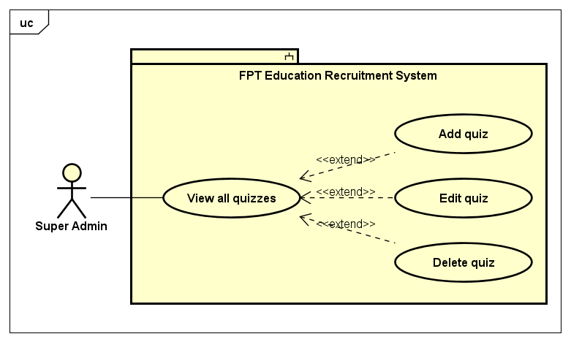

*Figure 13. Quiz management use cases*

|  |  |  |  |  |
| --- | --- | --- | --- | --- |
| **USE CASE-34 SPECIFICATION** | | | | |
| **Use-case No.** | <UC34> | **Use-case Version** | | <1.0> |
| **Use-case Name** | View all quizzes | | | |
| **Author** | TungBT | | | |
| **Date** | 18/07/2020 | **Priority** | Low | |
| **Actor** | Super Admin | | | |
| **Summary** | Super Admin views list of all quizzes in the system | | | |
| **Goal** | View all quizzes | | | |
| **Triggers** | Click tab “Quản lý đề bài” in the sidebar | | | |
| **Preconditions** | User has successfully logged in to the system as the Super Admin role | | | |
| **Post Conditions** | System show list of quizzes | | | |
| **Main Success Scenario** | | | | |
| |  |  |  | | --- | --- | --- | | **Step** | **Actor Events** | **System Response** | | **1** | User logins as role of Super Admin |  | | **2** |  | Display account management page by default | | **3** | User clicks on “Quản lý đề bài” tab on the sidebar |  | | **4** |  | Display quiz management page, show list of all quizzes | | | | | |
| **Alternative Scenario** | | | | |
| **N/A** | | | | |
| **Exceptions** | N/A | | | |
| **Business Rules** | N/A | | | |

## ***2.2.3.35. Use case 35: Add quiz***

|  |  |  |  |  |
| --- | --- | --- | --- | --- |
| **USE CASE-35 SPECIFICATION** | | | | |
| **Use-case No.** | <UC35> | **Use-case Version** | | <1.0> |
| **Use-case Name** | Add quiz | | | |
| **Author** | TungBT | | | |
| **Date** | 18/07/2020 | **Priority** | Low | |
| **Actor** | Super Admin | | | |
| **Summary** | Super admin adds a new quiz into quiz bank | | | |
| **Goal** | Add a new quiz | | | |
| **Triggers** | User clicks on “Tạo đề mới” button on quiz management page | | | |
| **Preconditions** | User has successfully logged in to the system as the Super Admin role | | | |
| **Post Conditions** | Add a new quiz into quiz bank | | | |
| **Main Success Scenario** | | | | |
| |  |  |  | | --- | --- | --- | | **Step** | **Actor Events** | **System Response** | | **1** | Do a normal flow of UC-34 |  | | **2** |  | Display quiz management page | | **3** | User clicks on “Tạo đề mới” button |  | | **4** |  | Display add quiz page | | **5** | Enter the name of the quiz, then check the questions user want in that quiz, finally click “Tạo mới” button |  | | **6** |  | Notice of success and move to quiz management page | | | | | |
| **Alternative Scenario** | | | | |
| **N/A** | | | | |
| **Exceptions** | N/A | | | |
| **Business Rules** | A Quiz must have name and contain at least 1 question  * Max length of quiz name field is 255 * Quiz name must not be blank | | | |

## ***2.2.3.36. Use case 36: Edit quiz***

|  |  |  |  |  |
| --- | --- | --- | --- | --- |
| **USE CASE-36 SPECIFICATION** | | | | |
| **Use-case No.** | <UC36> | **Use-case Version** | | <1.0> |
| **Use-case Name** | Edit quiz | | | |
| **Author** | TungBT | | | |
| **Date** | 18/07/2020 | **Priority** | Low | |
| **Actor** | Super Admin | | | |
| **Summary** | Super Admin edit a quiz in quiz bank | | | |
| **Goal** | Edit a quiz | | | |
| **Triggers** | Click on “Sửa” button of a quiz | | | |
| **Preconditions** | User has successfully logged in to the system as the Super Admin role | | | |
| **Post Conditions** | Edit a quiz | | | |
| **Main Success Scenario** | | | | |
| |  |  |  | | --- | --- | --- | | **Step** | **Actor Events** | **System Response** | | **1** | Do a normal flow of UC-34 |  | | **2** |  | Display list of quizzes | | **3** | User clicks on “Sửa” button of a quiz |  | | **4** |  | Display edit quiz page | | **5** | User changes the name of quiz, adds or removes questions of the the quiz, then clicks on submit button to complete editing |  | | **6** |  | Notice of success and back to manage quiz page | | | | | |
| **Alternative Scenario** | | | | |
| **N/A** | | | | |
| **Exceptions** | N/A | | | |
| **Business Rules** | A Quiz must have name and contain at least 1 question  * Max length of quiz name field is 255 * Quiz name must not be blank | | | |

## ***2.2.3.37. Use case 37: Delete quiz***

|  |  |  |  |  |
| --- | --- | --- | --- | --- |
| **USE CASE-37 SPECIFICATION** | | | | |
| **Use-case No.** | <UC37> | **Use-case Version** | | <1.0> |
| **Use-case Name** | Delete quiz | | | |
| **Author** | TungBT | | | |
| **Date** | 18/07/2020 | **Priority** | Low | |
| **Actor** | Super Admin | | | |
| **Summary** | Super Admin deletes a quiz in quiz bank | | | |
| **Goal** | Delete a quiz | | | |
| **Triggers** | Click on “Xóa” button of a quiz | | | |
| **Preconditions** | User has successfully logged in to the system as the Super Admin role | | | |
| **Post Conditions** | Delete a quiz | | | |
| **Main Success Scenario** | | | | |
| |  |  |  | | --- | --- | --- | | **Step** | **Actor Events** | **System Response** | | **1** | Do a normal flow of UC-34 |  | | **2** |  | Display list of quizzes | | **3** | User clicks on “Xóa” button of a quiz |  | | **4** |  | Give a confirmation dialog box | | **5** | User clicks OK to delete the quiz |  | | **6** |  | Delete successfully and refresh page | | | | | |
| **Alternative Scenario** | | | | |
| **N/A** | | | | |
| **Exceptions** | N/A | | | |
| **Business Rules** | N/A | | | |

## 

## ***2.2.3.38. Use case 38: View all careers***

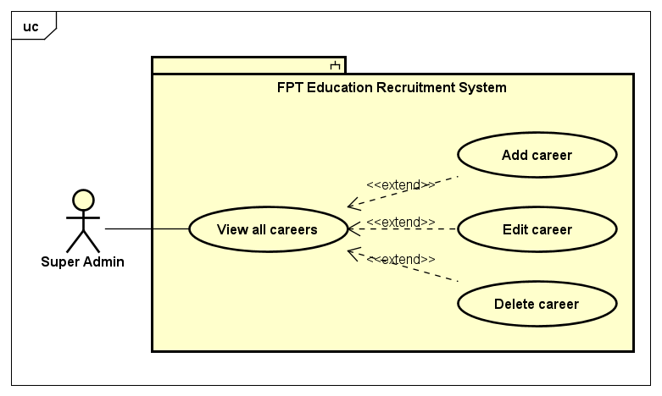

*Figure 14. Career use cases*

## 

|  |  |  |  |  |
| --- | --- | --- | --- | --- |
| **USE CASE-38 SPECIFICATION** | | | | |
| **Use-case No.** | <UC38> | **Use-case Version** | | <1.0> |
| **Use-case Name** | View all careers | | | |
| **Author** | TungBT | | | |
| **Date** | 18/07/2020 | **Priority** | Low | |
| **Actor** | Super Admin | | | |
| **Summary** | Super Admin views list of all careers in the system | | | |
| **Goal** | View list of all careers | | | |
| **Triggers** | User clicks on the tab “Quản lý nghề nghiệp” on the sidebar | | | |
| **Preconditions** | User has successfully logged in to the system as the Super Admin role | | | |
| **Post Conditions** | View all careers | | | |
| **Main Success Scenario** | | | | |
| |  |  |  | | --- | --- | --- | | **Step** | **Actor Events** | **System Response** | | **1** | User logins the system as role of Super Admin |  | | **2** |  | Display admin homepage with account management tab default | | **3** | User clicks on “Quản lý nghề nghiệp” tab |  | | **4** |  | Display career management page | | | | | |
| **Alternative Scenario** | | | | |
| N/A | | | | |
| **Exceptions** | N/A | | | |
| **Business Rules** | N/A | | | |

## ***2.2.3.39. Use case 39: Add career***

|  |  |  |  |  |
| --- | --- | --- | --- | --- |
| **USE CASE-39 SPECIFICATION** | | | | |
| **Use-case No.** | <UC39> | **Use-case Version** | | <1.0> |
| **Use-case Name** | Add career | | | |
| **Author** | TungBT | | | |
| **Date** | 18/07/2020 | **Priority** | Low | |
| **Actor** | Super Admin | | | |
| **Summary** | Super Admin adds a new career into the system | | | |
| **Goal** | Add a new career | | | |
| **Triggers** | User clicks on “Tạo nghề nghiệp mới” button on career management page | | | |
| **Preconditions** | User has successfully logged in to the system as the Super Admin role | | | |
| **Post Conditions** | Add a new career into the system | | | |
| **Main Success Scenario** | | | | |
| |  |  |  | | --- | --- | --- | | **Step** | **Actor Events** | **System Response** | | **1** | Do a normal flow of UC-38 |  | | **2** |  | Display career management page | | **3** | Click on “Tạo nghề nghiệp mới” button |  | | **4** |  | Display add career page | | **5** | Enter name of new career then click “Tạo mới” |  | | **6** |  | Notice of success, display career management page | | | | | |
| **Alternative Scenario** | | | | |
| **N/A** | | | | |
| **Exceptions** | N/A | | | |
| **Business Rules** | Career name must not be blank  * Maximum length of career name is 255 | | | |

## ***2.2.3.40. Use case 40: Edit career***

|  |  |  |  |  |
| --- | --- | --- | --- | --- |
| **USE CASE-40 SPECIFICATION** | | | | |
| **Use-case No.** | <UC40> | **Use-case Version** | | <1.0> |
| **Use-case Name** | Edit career | | | |
| **Author** | TungBT | | | |
| **Date** | 18/07/2020 | **Priority** | Low | |
| **Actor** | Super Admin | | | |
| **Summary** | Super Admin edits information of a career | | | |
| **Goal** | Edit information of a career | | | |
| **Triggers** | Click on “Sửa” button of a career | | | |
| **Preconditions** | User has successfully logged in to the system as the Super Admin role | | | |
| **Post Conditions** | Edit a career | | | |
| **Main Success Scenario** | | | | |
| |  |  |  | | --- | --- | --- | | **Step** | **Actor Events** | **System Response** | | **1** | Do a normal flow of UC-38 |  | | **2** |  | Display career management page | | **3** | User clicks on “Sửa” button of a career |  | | **4** |  | Display edit career page | | **5** | User changes the name of career then clicks on “Lưu” button to complete editing |  | | **6** |  | Notice of success, display career management page | | | | | |
| **Alternative Scenario** | | | | |
| N/A | | | | |
| **Exceptions** | N/A | | | |
| **Business Rules** | N/A | | | |

## ***2.2.3.41. Use case 41: Delete career***

|  |  |  |  |  |
| --- | --- | --- | --- | --- |
| **USE CASE-41 SPECIFICATION** | | | | |
| **Use-case No.** | <UC41> | **Use-case Version** | | <1.0> |
| **Use-case Name** | Delete career | | | |
| **Author** | TungBT | | | |
| **Date** | 18/07/2020 | **Priority** | Low | |
| **Actor** | Super Admin | | | |
| **Summary** | Super Admin deletes a career in the system | | | |
| **Goal** | Delete a career | | | |
| **Triggers** | Click on “Xóa” button of a career | | | |
| **Preconditions** | User has successfully logged in to the system as the Super Admin role | | | |
| **Post Conditions** | Delete a career | | | |
| **Main Success Scenario** | | | | |
| |  |  |  | | --- | --- | --- | | **Step** | **Actor Events** | **System Response** | | **1** | Do a normal flow of UC-38 |  | | **2** |  | Display career management page | | **3** | User clicks on “Xóa” button of a career |  | | **4** |  | Give a confirmation dialog box | | **5** | User clicks OK to delete the career |  | | **6** |  | Delete successfully and refresh page | | | | | |
| **Alternative Scenario** | | | | |
| **N/A** | | | | |
| **Exceptions** | N/A | | | |
| **Business Rules** | N/A | | | |

## 

## ***2.2.3.42. Use case 42: View all config emails***

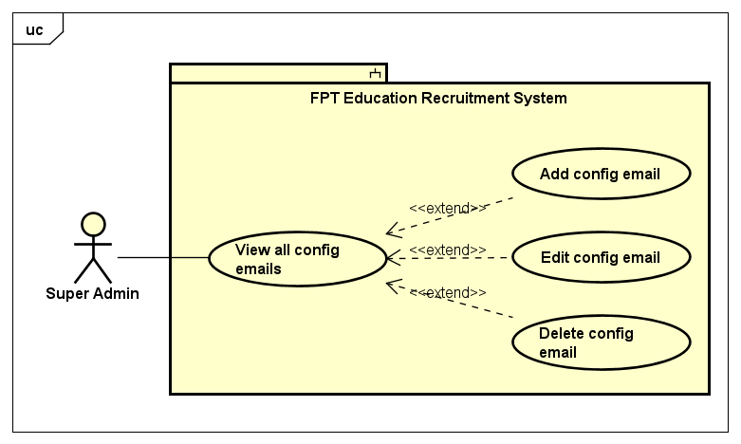

*Figure 15. Email management use cases*

## 

|  |  |  |  |  |
| --- | --- | --- | --- | --- |
| **USE CASE-42 SPECIFICATION** | | | | |
| **Use-case No.** | <UC42> | **Use-case Version** | | <1.0> |
| **Use-case Name** | View all config emails | | | |
| **Author** | TungBT | | | |
| **Date** | 18/07/2020 | **Priority** | Low | |
| **Actor** | Super Admin | | | |
| **Summary** | Super Admin views list of all config emails that will be used automatically to send emails for candidates | | | |
| **Goal** | View list of all config emails | | | |
| **Triggers** | Super Admin clicks tab “Quản lý gửi mail” on the sidebar of admin page | | | |
| **Preconditions** | User has successfully logged in to the system as the Super Admin role | | | |
| **Post Conditions** | Super Admin views list of all config emails | | | |
| **Main Success Scenario** | | | | |
| |  |  |  | | --- | --- | --- | | **Step** | **Actor Events** | **System Response** | | **1** | User logins as Super Admin role |  | | **2** |  | Display account management page by default | | **3** | User clicks on “Quản lý gửi mail” tab on the sidebar |  | | **4** |  | Display email management page | | | | | |
| **Alternative Scenario** | | | | |
| **N/A** | | | | |
| **Exceptions** | N/A | | | |
| **Business Rules** | N/A | | | |

## 

## ***2.2.3.43. Use case 43: Add config email***

|  |  |  |  |  |
| --- | --- | --- | --- | --- |
| **USE CASE-43 SPECIFICATION** | | | | |
| **Use-case No.** | <UC43> | **Use-case Version** | | <1.0> |
| **Use-case Name** | Add config email | | | |
| **Author** | TungBT | | | |
| **Date** | 18/07/2020 | **Priority** | Low | |
| **Actor** | Super Admin | | | |
| **Summary** | Super admin adds a new email into list of emails that will be used automatically to send emails for candidates | | | |
| **Goal** | Add a new email | | | |
| **Triggers** | User clicks on “Tạo tài khoản gửi mail mới” button on email management page | | | |
| **Preconditions** | User has successfully logged in to the system as the Super Admin role | | | |
| **Post Conditions** | Add a new email | | | |
| **Main Success Scenario** | | | | |
| |  |  |  | | --- | --- | --- | | **Step** | **Actor Events** | **System Response** | | **1** | Do a normal flow of UC-42 |  | | **2** |  | Display config email management page | | **3** | Click on “Tạo tài khoản gửi mail mới” button |  | | **4** |  | Display add config email page | | **5** | Enter information of a new config email includes:   * Name of email * Password * Port number * Host * Is enable SSL * Is active   then click “Tạo mới” button |  | | **6** |  | Notice of success and display email management page | | | | | |
| **Alternative Scenario** | | | | |
| **N/A** | | | | |
| **Exceptions** | N/A | | | |
| **Business Rules** | Email, password, port, host must not be blank | | | |

## ***2.2.3.44. Use case 44: Edit email***

|  |  |  |  |  |
| --- | --- | --- | --- | --- |
| **USE CASE-44 SPECIFICATION** | | | | |
| **Use-case No.** | <UC44> | **Use-case Version** | | <1.0> |
| **Use-case Name** | Edit config email | | | |
| **Author** | TungBT | | | |
| **Date** | 18/07/2020 | **Priority** | Low | |
| **Actor** | Super Admin | | | |
| **Summary** | Super Admin edits information of an email | | | |
| **Goal** | Edit information of a config email | | | |
| **Triggers** | Click on “Sửa” button of an email | | | |
| **Preconditions** | User has successfully logged in to the system as the Super Admin role | | | |
| **Post Conditions** | Edit an email | | | |
| **Main Success Scenario** | | | | |
| |  |  |  | | --- | --- | --- | | **Step** | **Actor Events** | **System Response** | | **1** | Do a normal flow of UC-42 |  | | **2** |  | Display email management page | | **3** | Click on “Sửa” button of an email |  | | **4** |  | Display edit email page | | **5** | Edit information of the email includes:   * Name of email * Password * Port number * Host * Is enable SSL * Is active |  | | **6** | Click “Lưu” button |  | |  |  | Notice of success then display email management page | | | | | |
| **Alternative Scenario** | | | | |
| **N/A** | | | | |
| **Exceptions** | N/A | | | |
| **Business Rules** | Email, password, port, host must not be blank | | | |

## ***2.2.3.45. Use case 45: Delete email***

|  |  |  |  |  |
| --- | --- | --- | --- | --- |
| **USE CASE-45 SPECIFICATION** | | | | |
| **Use-case No.** | <UC45> | **Use-case Version** | | <1.0> |
| **Use-case Name** | Delete config email | | | |
| **Author** | TungBT | | | |
| **Date** | 18/07/2020 | **Priority** | Low | |
| **Actor** | Super Admin | | | |
| **Summary** | Super Admin deletes an email | | | |
| **Goal** | Delete an email | | | |
| **Triggers** | Click on “Xóa” button on an email | | | |
| **Preconditions** | User has successfully logged in to the system as the Super Admin role | | | |
| **Post Conditions** | Delete an email | | | |
| **Main Success Scenario** | | | | |
| |  |  |  | | --- | --- | --- | | **Step** | **Actor Events** | **System Response** | | **1** | Do a normal flow of UC-42 |  | | **2** |  | Display email management page | | **3** | User clicks on “Xóa” button on an email |  | | **4** |  | Give confirmation dialog box | | **5** | Confirm to delete the email |  | | **6** |  | Delete the email then display email management page | | | | | |
| **Alternative Scenario** | | | | |
| **N/A** | | | | |
| **Exceptions** | N/A | | | |
| **Business Rules** | N/A | | | |

## 

## ***2.2.3.46. Use case 46: View logs***

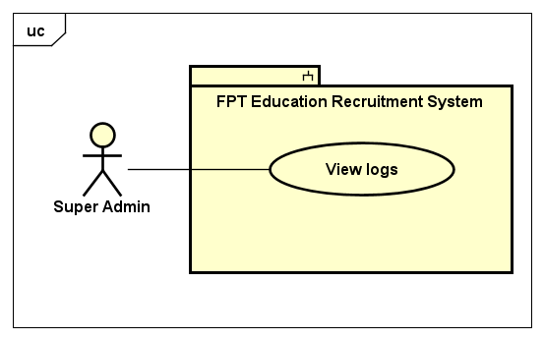

*Figure 16. View logs use case*

## 

|  |  |  |  |  |
| --- | --- | --- | --- | --- |
| **USE CASE-46 SPECIFICATION** | | | | |
| **Use-case No.** | <UC46> | **Use-case Version** | | <1.0> |
| **Use-case Name** | View logs | | | |
| **Author** | TungBT | | | |
| **Date** | 18/07/2020 | **Priority** | Medium | |
| **Actor** | Super Admin | | | |
| **Summary** | When any system changes take place (update accounts, add unit, ...), it is logged, the user can view the changes. | | | |
| **Goal** | View system changes | | | |
| **Triggers** | User clicks on “Quản lý log” tab on the sidebar | | | |
| **Preconditions** | User has successfully logged in to the system as the Super Admin role | | | |
| **Post Conditions** | View log about system changes | | | |
| **Main Success Scenario** | | | | |
| |  |  |  | | --- | --- | --- | | **Step** | **Actor Events** | **System Response** | | **1** | User logins to the system as role of Super Admin |  | | **2** |  | Display account management page by default | | **3** | User clicks on the tab “Quản lý log” |  | | **4** |  | Display view log page | | | | | |
| **Alternative Scenario** | | | | |
| **N/A** | | | | |
| **Exceptions** | N/A | | | |
| **Business Rules** | N/A | | | |

## 

## ***2.2.3.47. Common use case***



*Figure 17. Common use cases*

## 

|  |  |  |  |  |
| --- | --- | --- | --- | --- |
| **USE CASE-47 SPECIFICATION** | | | | |
| **Use-case No.** | <UC47> | **Use-case Version** | | <1.0> |
| **Use-case Name** | Login | | | |
| **Author** | TungBT | | | |
| **Date** | 18/07/2020 | **Priority** | High | |
| **Actor** | Super Admin, HR Staff | | | |
| **Summary** | User logins to FERS website as role of Super Admin or HR Staff | | | |
| **Goal** | Login to FERS website | | | |
| **Triggers** | Users access the link "[career.fpt.edu.vn](http://www.career.fpt.edu.vn/Admin/Login)[/Account/Login](http://www.career.fpt.edu.vn/Account/Login)" | | | |
| **Preconditions** | N/A | | | |
| **Post Conditions** | Login to FERS website | | | |
| **Main Success Scenario** | | | | |
| |  |  |  | | --- | --- | --- | | **Step** | **Actor Events** | **System Response** | | **1** | User accesses the link "[career.fpt.edu.vn/Account/Login](http://www.career.fpt.edu.vn/Account/Login)" |  | | **2** |  | Display login page | | **3** | User clicks on the button “Đăng nhập” |  | | **4** |  | Pop up Google Authentication dialog box, this dialog box will show list of emails account of user to login | | **5** | User clicks on the email that was registered on the system |  | | **6** |  | Display management page with functions depending on account role | | | | | |
| **Alternative Scenario** | | | | |
| **N/A** | | | | |
| **Exceptions** | N/A | | | |
| **Business Rules** | N/A | | | |

## ***2.2.3.48. Use case 48: Logout***

|  |  |  |  |  |
| --- | --- | --- | --- | --- |
| **USE CASE-48 SPECIFICATION** | | | | |
| **Use-case No.** | <UC48> | **Use-case Version** | | <1.0> |
| **Use-case Name** | Logout | | | |
| **Author** | TungBT | | | |
| **Date** | 18/07/2020 | **Priority** | Low | |
| **Actor** | Super Admin / HR Staff | | | |
| **Summary** | User logs out of the system | | | |
| **Goal** | Log out of the system | | | |
| **Triggers** | User clicks on the button “Đăng xuất” | | | |
| **Preconditions** | User successfully logged into the system | | | |
| **Post Conditions** | Log out of the system | | | |
| **Main Success Scenario** | | | | |
| |  |  |  | | --- | --- | --- | | **Step** | **Actor Events** | **System Response** | | **1** | User click on the button “Đăng xuất” on the right top of page |  | | **2** |  | Log out the user from the system and move to the login page | | | | | |
| **Alternative Scenario** | | | | |
| **N/A** | | | | |
| **Exceptions** | N/A | | | |
| **Business Rules** | N/A | | | |

## 

## ***2.2.3.49. Use case 49: View all CVs***

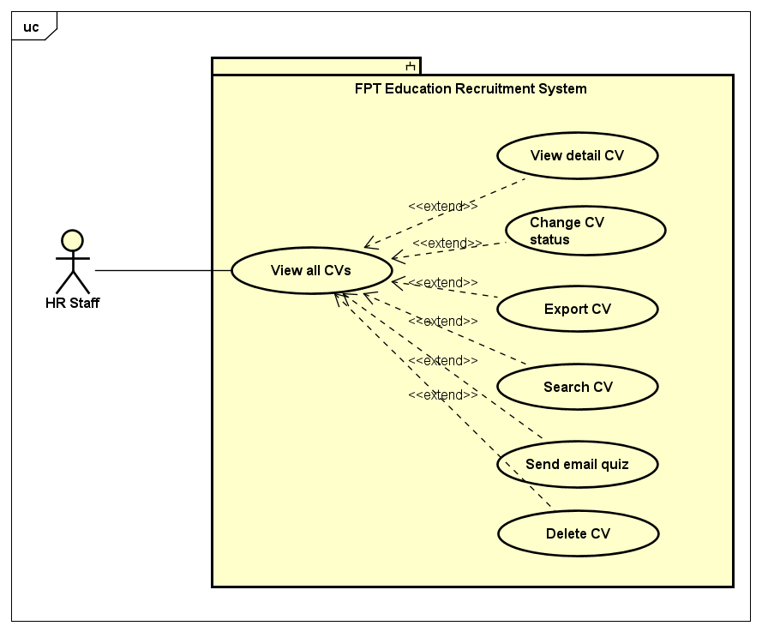

*Figure 18. CV management use cases*

## 

|  |  |  |  |  |
| --- | --- | --- | --- | --- |
| **USE CASE-49 SPECIFICATION** | | | | |
| **Use-case No.** | <UC-49> | **Use-case Version** | | <1.0> |
| **Use-case Name** | View all CVs | | | |
| **Author** | TungBT | | | |
| **Date** | 18/07/2020 | **Priority** | Medium | |
| **Actor** | HR Staff | | | |
| **Summary** | HR Staff views list of all CVs that was submitted to the system | | | |
| **Goal** | View list of all CVs | | | |
| **Triggers** | Click on the tab “Quản lý CV” on the sidebar | | | |
| **Preconditions** | User has successfully logged in to the system as the HR Staff role | | | |
| **Post Conditions** | View list of all CVs | | | |
| **Main Success Scenario** | | | | |
| |  |  |  | | --- | --- | --- | | **Step** | **Actor Events** | **System Response** | | **1** | User logs in to the system as role of HR Staff |  | | **2** |  | Display job management page as default | | **3** | Click on the tab “Quản lý CV” on the sidebar of website |  | | **4** |  | Display CV management page | | | | | |
| **Alternative Scenario** | | | | |
| **N/A** | | | | |
| **Exceptions** | N/A | | | |
| **Business Rules** | N/A | | | |

## ***2.2.3.50. Use case 50: View detail CV***

|  |  |  |  |  |
| --- | --- | --- | --- | --- |
| **USE CASE-50 SPECIFICATION** | | | | |
| **Use-case No.** | <UC50> | **Use-case Version** | | <1.0> |
| **Use-case Name** | View detail CV | | | |
| **Author** | TungBT | | | |
| **Date** | 18/07/2020 | **Priority** | Medium | |
| **Actor** | HR Staff | | | |
| **Summary** | HR Staff views detailed information about the candidate | | | |
| **Goal** | View detailed information about candidate | | | |
| **Triggers** | User clicks on the eye icon of a CV | | | |
| **Preconditions** | User has successfully logged in to the system as the HR Staff role | | | |
| **Post Conditions** | A dialog box will pop up and display information about CV | | | |
| **Main Success Scenario** | | | | |
| |  |  |  | | --- | --- | --- | | **Step** | **Actor Events** | **System Response** | | **1** | Do a normal flow of UC-49 |  | | **2** |  | Display CV management page | | **3** | User clicks on the eye icon of a CV |  | | **4** |  | Pop up a dialog box with detailed information about the CV | | | | | |
| **Alternative Scenario** | | | | |
| **N/A** | | | | |
| **Exceptions** | N/A | | | |
| **Business Rules** | N/A | | | |

## ***2.2.3.51. Use case 51: Change CV status***

|  |  |  |  |  |
| --- | --- | --- | --- | --- |
| **USE CASE-51 SPECIFICATION** | | | | |
| **Use-case No.** | <UC51> | **Use-case Version** | | <1.0> |
| **Use-case Name** | Change CV status | | | |
| **Author** | TungBT | | | |
| **Date** | 18/07/2020 | **Priority** | High | |
| **Actor** | HR Staff | | | |
| **Summary** | CV is divided into groups with different statuses for easy management. HR Staff can change status of CV | | | |
| **Goal** | Change status of the CV | | | |
| **Triggers** | User clicks on the status options then change it to another option | | | |
| **Preconditions** | User has successfully logged in to the system as the HR Staff role | | | |
| **Post Conditions** | Change status of the CV | | | |
| **Main Success Scenario** | | | | |
| |  |  |  | | --- | --- | --- | | **Step** | **Actor Events** | **System Response** | | **1** | Do a normal flow of UC-49 |  | | **2** |  | Display CV management page | | **3** | User clicks on the status options of a CV |  | | **4** |  | Drop down a list of status | | **5** | User changes the status of the CV to the state he/she wants. There are 5 states:   * “Mới” * “Đã xem” * “Xem xét” * “Chấp nhận” * “Từ chối” |  | | **6** |  | The system notifies the successful status change, and simultaneously changes the color of the CV status | | | | | |
| **Alternative Scenario** | | | | |
| **N/A** | | | | |
| **Exceptions** | N/A | | | |
| **Business Rules** | It’s possible to change from current state to any other state | | | |

## 

## ***2.2.3.52. Use case 52: Search CV***

|  |  |  |  |  |
| --- | --- | --- | --- | --- |
| **USE CASE-52 SPECIFICATION** | | | | |
| **Use-case No.** | <UC52> | **Use-case Version** | | <1.0> |
| **Use-case Name** | Search CV | | | |
| **Author** | TungBT | | | |
| **Date** | 18/07/2020 | **Priority** | Medium | |
| **Actor** | HR Staff | | | |
| **Summary** | HR Staff search for a CV that he/she wants, searching keywords include:  * Job title * Candidate name * Email * Start date * End date * CV status | | | |
| **Goal** | Search a CV | | | |
| **Triggers** | User enters the search keyword on the search menu bar and then clicks search button | | | |
| **Preconditions** | User has successfully logged in to the system as the HR Staff role | | | |
| **Post Conditions** | Search a CV | | | |
| **Main Success Scenario** | | | | |
| |  |  |  | | --- | --- | --- | | **Step** | **Actor Events** | **System Response** | | **1** | Do a normal flow of UC-49 |  | | **2** |  | Display CV management page | | **3** | User enters the search keywords and then click search button |  | | **4** |  | Display list of CV filtered by keyword search | | | | | |
| **Alternative Scenario** | | | | |
| **N/A** | | | | |
| **Exceptions** | N/A | | | |
| **Business Rules** | Maximum length of job title, email, candidate name field is 255 | | | |

## 

## ***2.2.3.53. Use case 53: Delete CV***

|  |  |  |  |  |
| --- | --- | --- | --- | --- |
| **USE CASE-53 SPECIFICATION** | | | | |
| **Use-case No.** | <UC53> | **Use-case Version** | | <1.0> |
| **Use-case Name** | Delete CV | | | |
| **Author** | TungBT | | | |
| **Date** | 18/07/2020 | **Priority** | Low | |
| **Actor** | HR Staff | | | |
| **Summary** | HR Staff deletes a CV of the candidate | | | |
| **Goal** | Delete a CV | | | |
| **Triggers** | Click on the button “Xóa” of a CV | | | |
| **Preconditions** | User has successfully logged in to the system as the HR Staff role | | | |
| **Post Conditions** | Delete a CV | | | |
| **Main Success Scenario** | | | | |
| |  |  |  | | --- | --- | --- | | **Step** | **Actor Events** | **System Response** | | **1** | Do a normal flow of UC-49 |  | | **2** |  | Display CV management page | | **3** | User clicks button “Xóa” on a CV |  | | **4** |  | Give confirmation message | | **5** | Clicks OK to confirm delete the CV |  | | **6** |  | Delete the CV then reload page | | | | | |
| **Alternative Scenario** | | | | |
| **N/A** | | | | |
| **Exceptions** | N/A | | | |
| **Business Rules** | N/A | | | |

## 

## ***2.2.3.54. Use case 54: Send email quiz***

|  |  |  |  |  |
| --- | --- | --- | --- | --- |
| **USE CASE-54 SPECIFICATION** | | | | |
| **Use-case No.** | <UC54> | **Use-case Version** | | <1.0> |
| **Use-case Name** | Send email quiz | | | |
| **Author** | TungBT | | | |
| **Date** | 18/07/2020 | **Priority** | Medium | |
| **Actor** | HR Staff | | | |
| **Summary** | After candidate submitted CV to the system, HR Staff can email the quiz link to candidates that they want | | | |
| **Goal** | Send an email that contains the link of quiz | | | |
| **Triggers** | Click on the button “Chưa gửi, gửi ngay” on CV management page | | | |
| **Preconditions** | User has successfully logged in to the system as the HR Staff role | | | |
| **Post Conditions** | Send an email that contains the link of quiz | | | |
| **Main Success Scenario** | | | | |
| |  |  |  | | --- | --- | --- | | **Step** | **Actor Events** | **System Response** | | **1** | Do a normal flow of UC-49 |  | | **2** |  | Display CV management page | | **3** | In the quiz score column, for candidates who have not taken the quiz, there is a button "Chưa gửi, gửi ngay". User clicks the button |  | | **4** |  | Send an email that contains the quiz link to candidate | | | | | |
| **Alternative Scenario** | | | | |
| **N/A** | | | | |
| **Exceptions** | N/A | | | |
| **Business Rules** | N/A | | | |

## 

## ***2.2.3.55. Use case 55: Export CV***

|  |  |  |  |  |
| --- | --- | --- | --- | --- |
| **USE CASE-55 SPECIFICATION** | | | | |
| **Use-case No.** | <UC55> | **Use-case Version** | | <1.0> |
| **Use-case Name** | Export CV | | | |
| **Author** | TungBT | | | |
| **Date** | 18/07/2020 | **Priority** | Medium | |
| **Actor** | HR Staff | | | |
| **Summary** | When HR staff wants to export the CV list to an excel file for easy management, he/she just needs to click “Xuất ra Excel” button | | | |
| **Goal** | Export list of CV to excel file | | | |
| **Triggers** | User clicks on the button “Xuất ra Excel” | | | |
| **Preconditions** | User has successfully logged in to the system as the HR Staff role | | | |
| **Post Conditions** | Export list of CV to excel file | | | |
| **Main Success Scenario** | | | | |
| |  |  |  | | --- | --- | --- | | **Step** | **Actor Events** | **System Response** | | **1** | Do a normal flow of UC-49 |  | | **2** |  | Display CV management page | | **3** | Clicks on the button “Xuất ra Excel” |  | | **4** |  | Export the CV to excel file.  The excel file will be automatically downloaded on browser | | | | | |
| **Alternative Scenario** | | | | |
| **N/A** | | | | |
| **Exceptions** | N/A | | | |
| **Business Rules** | N/A | | | |

## 

## ***2.2.3.56. Use case 56: View all jobs***

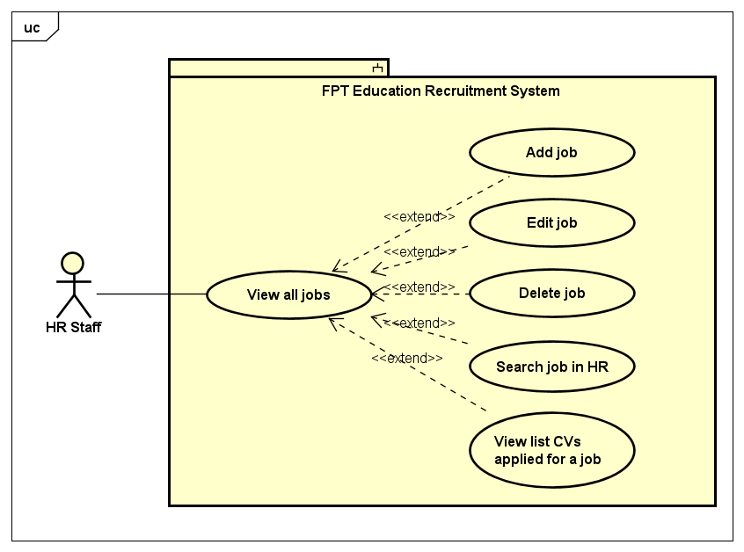

*Figure 19. Job management use cases*

|  |  |  |  |  |
| --- | --- | --- | --- | --- |
| **USE CASE-56 SPECIFICATION** | | | | |
| **Use-case No.** | <UC56> | **Use-case Version** | | <1.0> |
| **Use-case Name** | View all jobs | | | |
| **Author** | DatTQ | | | |
| **Date** | 18/07/2020 | **Priority** | Medium | |
| **Actor** | HR Staff | | | |
| **Summary** | HR Staff views all jobs which are managed and based on the location of HR Staff can manage in the system. | | | |
| **Goal** | HR Staff views all jobs in the system | | | |
| **Triggers** | HR Staff click tab “Quản lý tin tuyển dụng” on the sidebar of HR Staff page | | | |
| **Preconditions** | User has successfully logged in to the system as the HR Staff role | | | |
| **Post Conditions** | View all job are managed by login HR Staff | | | |
| **Main Success Scenario** | | | | |
| |  |  |  | | --- | --- | --- | | **Step** | **Actor Events** | **System Response** | | **1** | User login as role of HR Staff |  | | **2** |  | Display HR Staff homepage with job management tab default | | | | | |
| **Alternative Scenario** | | | | |
| **N/A** | | | | |
| **Exceptions** | N/A | | | |
| **Business Rules** | N/A | | | |

## ***2.2.3.57. Use case 57: Add job***

|  |  |  |  |  |
| --- | --- | --- | --- | --- |
| **USE CASE-57 SPECIFICATION** | | | | |
| **Use-case No.** | <UC57> | **Use-case Version** | | <1.0> |
| **Use-case Name** | Add job | | | |
| **Author** | DatTQ | | | |
| **Date** | 18/07/2020 | **Priority** | High | |
| **Actor** | HR Staff | | | |
| **Summary** | HR Staff add a job to the system | | | |
| **Goal** | Add new job | | | |
| **Triggers** | HR Staff click “Tạo việc mới” button on Job management page | | | |
| **Preconditions** | User has successfully logged in to the system as the HR Staff role | | | |
| **Post Conditions** | Add a new job to the system | | | |
| **Main Success Scenario** | | | | |
| |  |  |  | | --- | --- | --- | | **Step** | **Actor Events** | **System Response** | | **1** | Do a normal flow of UC-56 |  | | **2** |  | Display job management page | | **3** | Click “Tạo việc mới” button |  | | **4** |  | Display create job page | | **5** | Fill in all input fields and submit form |  | | **6** |  | If create success, the system will redirect to job manage page and notify success message  If create error, the system will redirect to error page and show message of error | | | | | |
| **Alternative Scenario** | | | | |
| **N/A** | | | | |
| **Exceptions** | **SQL Exception**  * the system will redirect to error page and show information of the exception | | | |
| **Business Rules** | HR Staff must fill all input required | | | |

## ***2.2.3.58. Use case 58: Edit job***

|  |  |  |  |  |
| --- | --- | --- | --- | --- |
| **USE CASE-58 SPECIFICATION** | | | | |
| **Use-case No.** | <UC58> | **Use-case Version** | | <1.0> |
| **Use-case Name** | Edit job | | | |
| **Author** | DatTQ | | | |
| **Date** | 18/07/2020 | **Priority** | Medium | |
| **Actor** | HR Staff | | | |
| **Summary** | HR Staff edits a job in the system | | | |
| **Goal** | Edit a exist job | | | |
| **Triggers** | HR Staff clicks “Sửa” button on an job when view all job | | | |
| **Preconditions** | User has successfully logged in to the system as the HR Staff role | | | |
| **Post Conditions** | Edit information about an job | | | |
| **Main Success Scenario** | | | | |
| |  |  |  | | --- | --- | --- | | **Step** | **Actor Events** | **System Response** | | **1** | Do a normal flow of UC-56 |  | | **2** |  | Display all jobs of the system | | **3** | Click “Sửa” button on a job |  | | **4** |  | Display edit job page | | **5** | Edit information of job and submit |  | | **6** |  | If edit success, the system will show notice of success and back to account management page  If edit error, the system will redirect to error page and show information of the error | | | | | |
| **Alternative Scenario** | | | | |
| **N/A** | | | | |
| **Exceptions** | **SQL Exception**  * the system will redirect to error page and show information of the exception | | | |
| **Business Rules** | Hr Staff must fill all input required. | | | |

## ***2.2.3.59. Use case 59: Delete job***

|  |  |  |  |  |
| --- | --- | --- | --- | --- |
| **USE CASE-59 SPECIFICATION** | | | | |
| **Use-case No.** | <UC59> | **Use-case Version** | | <1.0> |
| **Use-case Name** | Delete job | | | |
| **Author** | DatTQ | | | |
| **Date** | 18/07/2020 | **Priority** | Low | |
| **Actor** | HR Staff | | | |
| **Summary** | HR Staff deletes a job in the system | | | |
| **Goal** | Delete a job | | | |
| **Triggers** | HR Staff clicks “Xóa” button on Jobs management page | | | |
| **Preconditions** | User has successfully logged in to the system as the HR Staff role | | | |
| **Post Conditions** | Delete a job | | | |
| **Main Success Scenario** | | | | |
| |  |  |  | | --- | --- | --- | | **Step** | **Actor Events** | **System Response** | | **1** | Do a normal flow of UC-56 |  | | **2** |  | Display all jobs of the system | | **3** | Click “Xóa” button on an job |  | | **4** |  | Give confirmation message | | **5** | Confirm to delete the job |  | | **6** |  | Delete the job then reload page | | | | | |
| **Alternative Scenario** | | | | |
| **N/A** | | | | |
| **Exceptions** | N/A | | | |
| **Business Rules** | When HR Staff deletes a job which has CV applied, although the system doesn’t delete the job, the system will hide the job. | | | |

## ***2.2.3.60. Use case 60: Search job in HR***

|  |  |  |  |  |
| --- | --- | --- | --- | --- |
| **USE CASE-60 SPECIFICATION** | | | | |
| **Use-case No.** | <UC60> | **Use-case Version** | | <1.0> |
| **Use-case Name** | Search Job In HR | | | |
| **Author** | DatTQ | | | |
| **Date** | 18/07/2020 | **Priority** | Medium | |
| **Actor** | HR Staff | | | |
| **Summary** | HR Staff find jobs that he/she needs,searching keywords include:  * Job title * Unit * Career * Location | | | |
| **Goal** | Display list of jobs filter by some input searching | | | |
| **Triggers** | HR Staff choose the options in filter menu (Quản lý tin tuyển dụng) then click “Tìm kiếm” | | | |
| **Preconditions** | User has successfully logged in to the system as the HR Staff role | | | |
| **Post Conditions** | HR Staff find jobs that HR Staff needs | | | |
| **Main Success Scenario** | | | | |
| |  |  |  | | --- | --- | --- | | **Step** | **Actor Events** | **System Response** | | **1** | Do a normal flow of UC-56 |  | | **2** |  | Display job management page | | **3** | HR Staff enters the search keywords and then click “Tìm kiếm” button |  | | **4** |  | Display list of jobs filtered by keyword search | | | | | |
| **Alternative Scenario** | | | | |
| **N/A** | | | | |
| **Exceptions** | N/A | | | |
| **Business Rules** | Maximum length of job title name field is 255 | | | |

## ***2.2.3.61. Use case 61: View list CVs applied for a job***

|  |  |  |  |  |
| --- | --- | --- | --- | --- |
| **USE CASE-61 SPECIFICATION** | | | | |
| **Use-case No.** | <UC61> | **Use-case Version** | | <1.0> |
| **Use-case Name** | View list CVs applied for a job | | | |
| **Author** | TungBT | | | |
| **Date** | 18/07/2020 | **Priority** | Medium | |
| **Actor** | HR Staff | | | |
| **Summary** | When HR Staffs view list of all the jobs that are currently recruiting, they can see the number of CVs applied for a job, when clicking on the link the system will redirect to a new page - a list of all CVs applied for the job | | | |
| **Goal** | View list of all CVs applied for a job | | | |
| **Triggers** | Click to the number of CV applied for a job on Job management page | | | |
| **Preconditions** | User has successfully logged in to the system as the HR Staff role | | | |
| **Post Conditions** | View list of all CVs applied for a job | | | |
| **Main Success Scenario** | | | | |
| |  |  |  | | --- | --- | --- | | **Step** | **Actor Events** | **System Response** | | **1** | Do a normal flow of UC-56, view all jobs |  | | **2** |  | Display job management page | | **3** | User clicks to the number of CV applied for a job |  | | **4** |  | Redirect to CV management page, show list of all CVs applied for the job user clicked to | | | | | |
| **Alternative Scenario** | | | | |
| **N/A** | | | | |
| **Exceptions** | N/A | | | |
| **Business Rules** | N/A | | | |

## ***2.2.3.62. Use case 62: View all error emails***

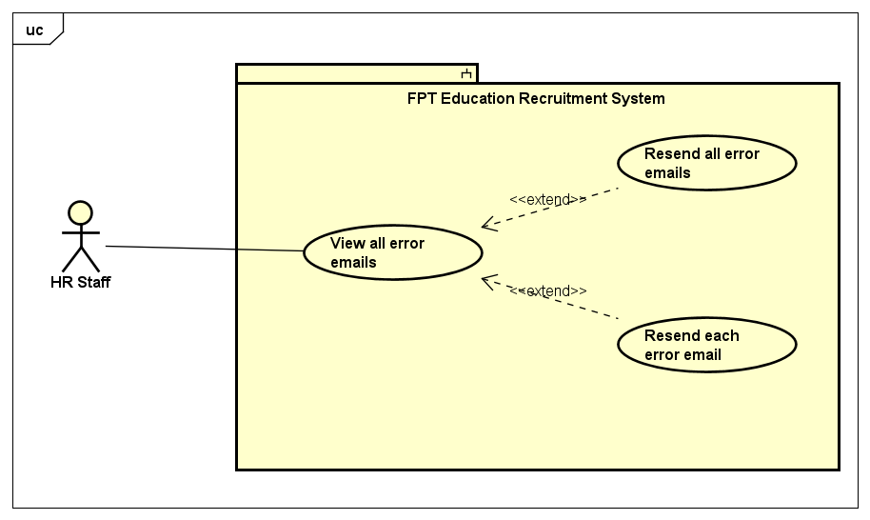

*Figure 20. Error email management use cases*

## 

|  |  |  |  |  |
| --- | --- | --- | --- | --- |
| **USE CASE-62 SPECIFICATION** | | | | |
| **Use-case No.** | <UC62> | **Use-case Version** | | <1.0> |
| **Use-case Name** | View all error emails | | | |
| **Author** | DatTQ | | | |
| **Date** | 18/07/2020 | **Priority** | Medium | |
| **Actor** | HR Staff | | | |
| **Summary** | Emailing candidates (successful application notification or quiz link) may be an error (the network does not allow or other reasons). HR Staff can review unsuccessful emails in the tab “Quản lý Email lỗi” | | | |
| **Goal** | HR Staff view list of error email | | | |
| **Triggers** | HR Staff click tab “Quản lý Email lỗi” on the sidebar of HR Staff page | | | |
| **Preconditions** | User has successfully logged in to the system as the HR Staff role | | | |
| **Post Conditions** | View all error email | | | |
| **Main Success Scenario** | | | | |
|  | | | | |
| **Alternative Scenario** | | | | |
| **N/A** | | | | |
| **Exceptions** | N/A | | | |
| **Business Rules** | N/A | | | |

## 

## ***2.2.3.63. Use case 63: Resend all error emails***

|  |  |  |  |  |
| --- | --- | --- | --- | --- |
| **USE CASE-63 SPECIFICATION** | | | | |
| **Use-case No.** | <UC63> | **Use-case Version** | | <1.0> |
| **Use-case Name** | Resend all error email | | | |
| **Author** | DatTQ | | | |
| **Date** | 18/07/2020 | **Priority** | Medium | |
| **Actor** | HR Staff | | | |
| **Summary** | Resend all the failed emails at once | | | |
| **Goal** | Resend all error email to candidates | | | |
| **Triggers** | HR Staff click tab “Gửi lại những Email lỗi” on error email management page | | | |
| **Preconditions** | User has successfully logged in to the system as the HR Staff role | | | |
| **Post Conditions** | Resend all error email to candidates | | | |
| **Main Success Scenario** | | | | |
| |  |  |  | | --- | --- | --- | | **Step** | **Actor Events** | **System Response** | | **1** | Do a normal flow of UC-62 |  | | **2** |  | Display Email management page | | **3** | Clicks on the button “Gửi lại những Email lỗi” |  | | **4** |  | Resend all error email to the candidates | | | | | |
| **Alternative Scenario** | | | | |
| **N/A** | | | | |
| **Exceptions** | IP address is not allowed to send mail from domain | | | |
| **Business Rules** | Must exist email of sender and received | | | |

## ***2.2.3.64. Use case 64: Resend each error email***

|  |  |  |  |  |
| --- | --- | --- | --- | --- |
| **USE CASE-64 SPECIFICATION** | | | | |
| **Use-case No.** | <UC64> | **Use-case Version** | | <1.0> |
| **Use-case Name** | Resend each error email | | | |
| **Author** | DatTQ | | | |
| **Date** | 18/07/2020 | **Priority** | Low | |
| **Actor** | HR Staff | | | |
| **Summary** | After reviewing the failed emails, HR Staff can just click resend email to a person they specify, no need to resend all email at once | | | |
| **Goal** | Resend a certain error email | | | |
| **Triggers** | HR Staff click the button “Gửi lại” of an error email | | | |
| **Preconditions** | User has successfully logged in to the system as the HR Staff role | | | |
| **Post Conditions** | Resend a certain error email | | | |
| **Main Success Scenario** | | | | |
| |  |  |  | | --- | --- | --- | | **Step** | **Actor Events** | **System Response** | | **1** | Do a normal flow of UC-62 |  | | **2** |  | Display email management page | | **3** | HR Staff click the button “Gửi lại” in an error email which he/she wants to resend |  | | **4** |  | Resend the email to candidate | | | | | |
| **Alternative Scenario** | | | | |
| **N/A** | | | | |
| **Exceptions** | IP address is not allowed to send mail from domain | | | |
| **Business Rules** | Must exist email of sender and received | | | |

## ***2.3. Non-functional Requirement***

## ***2.3.1 Reliability***

* All data entered by the user is validated before sending it to the server
* The system complies with business rules

***2.3.2 Availability***

N/A

## ***2.3.3 Security***

* The system must use Google accounts belonging to FPT organization and registered in the system to sign in.
* The system must use HTTPS to encrypt the information transferred between clients and servers.
* The system sends a quiz link via the candidate's email address and secured, authorized by a token generated by the system.
* The user authorization table is as follow:

|  |  |  |  |
| --- | --- | --- | --- |
| **Function** | **Super Admin** | **HR staff** | **Candidate** |
| Login | ✔ | ✔ |  |
| Logout | ✔ | ✔ |  |
| Manage accounts | ✔ |  |  |
| Manage quiz | ✔ |  |  |
| Manage careers | ✔ |  |  |
| Manage units | ✔ |  |  |
| Manage locations | ✔ |  |  |
| Manage questions | ✔ |  |  |
| Manage group question | ✔ |  |  |
| View log | ✔ |  |  |
| Manage configure email | ✔ |  |  |
| Manage CVs |  | ✔ |  |
| Manage Jobs |  | ✔ |  |
| Manage error email |  | ✔ |  |
| Apply job |  |  | ✔ |
| Do quiz |  |  | ✔ |

## ***2.3.4 Maintainability***

This system using .NET MVC 5, with the following advantages to maintain:

* A main advantage of MVC is separation of concern. Separation of concern means we divide the application Model, Control and View.
* We can easily maintain our application because of separation of concern.
* At the same time we can split many developers' work at a time. It will not affect one developer work to another developer work.
* It supports TTD (test-driven development). We can create an application with unit test. We can write won test case.

## ***2.3.5 Portability***

This system supports responsiveness for all screens: mobiles, desktops, tablets, laptops (For candidate view)

## **3. Entity Relationship Diagram**

## 